EGLINTON AVENUE AND QUEEN STREET

TRANSPORTATION CORRIDORS:

CONCEPT, COSTS, AND BENEFITS

L.D. Danny Harvey

and

Katharine Myrans

Department of Geography
University of Toronto
100 St. George Street
Toronto M5S 3G3

8 May 2003

Contact Information:

Phone: 416-978-1588
harvey@geog.utoronto.ca

Table of Contents

Preface and Acknowledgements 1

Executive Summary 3

Introduction 5

Estimating the cost of the Eglinton Avenue transportation corridor 19

Economic development potential along Eglinton Avenue 26

Estimating ridership on the Eglinton Avenue transit corridor 29

Configuration, cost, and potential ridership on the Queen Street subway 34

Implications for GO Transit 38

Impact on highways in Toronto 40

Construction techniques, geology, hydrology 41

Funding 42

References 44

Appendices

1: Maps of subway systems in selected cities 49

2: Photographs along Eglinton Avenue 65

3: Eglinton Avenue subway and LRT stops 73

4: Cost calculations for the Eglinton Avenue rapid transit corridor 75

5: Number of residents using the Eglinton Avenue transit corridor 81

6: Queen Street subway stops under Options 1 and 2 85

7: Cost of the Queen Street subway under Options 1 and 2 87

8: Subway tunnelling techniques 91

PREFACE AND ACKNOWLEDGEMENTS

We have prepared this report because we are not satisfied with current long-range thinking about transit options for the City of Toronto. We believe that the current thinking is not sufficiently bold and imaginative, and that current proposals fall short of what the citizens of the City of Toronto deserve and will need over the coming decades. Furthermore, current proposals do not represent an adequate response to the environmental problems that we face or the risks associated with high dependence on non-renewable transportation fuels, the seriousness of which is not fully appreciated by politicians, the media, and the public.

Neither one of us is a planner or transportation expert. However, we have followed the strategic planning process in Toronto and associated publicly-available discussion papers. In this document we present a number of entirely new ideas, as well as new perspectives on some old concepts. In so-doing, we hope to stimulate discussion about a much broader range of transit options for the City of Toronto than hitherto considered and, we hope, influence the direction of transit development in the City of Toronto.

In order to provide a preliminary analysis of the viability of our ideas, we have obtained crude estimates of the costs, ridership, and development potential associated with the two major subway lines that we propose, along Eglinton Avenue and Queen Street. We have used readily-available information, but would gladly welcome more detailed – and more accurate – estimates of these key characteristics of our proposed subway lines.

This paper is an outgrowth of a fourth-year independent-research project in the Department of Geography at the University of Toronto by the second author (Myrans) under the supervision of the first author (Harvey). In the process of undertaking that project, a wide number of people provided information, advice, and assistance, whom we wish to acknowledge here.

At the Toronto Transit Commission: Daniel Daligadu, Technical Assistant in the Engineering Department, for general assistance; Fulvio Fanti, Superintendent-Estimating of the Engineering Department, for providing cost figures and reviewing cost calculations; Gerrie Singh for assisting with TTC library materials; Weislaw Chojnacki for the opportunity to interview him and for miscellaneous references; Pierre Laurin for providing geotechnical information and maps; Peter Janas, for providing ridership information; Bernard Farrol for his response ridership questions; Doris Camilleri for proving contacts; Roger Toms and Stephanie Rice at the Sheppard Subway Offices for providing costing information; and Gerry Coveney for granting permission to perform research at the TTC.

At the City of Toronto: Greg Stewart and Janet Lo for their support, direction, and ideas; Peter Veducias for the time he took to discuss economic development in the city; and Loy Cheah for his assistance in hunting down transportation data.

At the University of Toronto: Professors Eric Miller, Sandy Cruden, Ken Howard, and Nicholas Eyles for their responses to emails and assistance in obtaining much needed resources, and Gerry Steuart of the Joint Programme in Transportation for providing highway traffic data.

Many thanks also go to the following: Micheal Roschlau, President and CEO of the Canadian Urban Transit Association for arranging access to the CUTA library; Michael Canzi, Technical Services Assistant, CUTA, for his time and help in locating library materials; Walter Trisi, Technical Sales Manager of Lovat Tunnel, for the generous information package he put together and his quick responses to questions; Leon Rakopoulos, Marketing/Advertising Coordinator, for the timely provision of an information package; Jason Ferrigan and Antony Lorius for their interview time and consulting documents; and to Mark Lesiw and Iain Myrans for technical assistance.

EXECUTIVE SUMMARY

Current discussion papers by the City of Toronto and the Toronto Transit Commission do not consider subway lines along Queen Street and Eglinton Avenue. However, these are the two routes in Toronto where new subway lines can be most strongly justified based on existing and potential additional transit use, and based on the extent to which subway lines on the these routes would support important urban planning goals (including urban intensification in the case of an Eglinton subway line and redevelopment of the waterfront in the case of a Queen subway line). Here, we offer new ideas and concepts involving rail-based transportation corridors along Eglinton Avenue and Queen Street that lead to better service and lower cost than conventional subway lines along these routes.

We envisage the development of Eglinton Avenue and Queen Street transportation corridors within the context of an aggressive GTA-wide programme to vastly improve rail-based transit by spending 1% of the regional GNP per year ($1.81 billion/yr, compared to a regional GNP of $182 billion in 2000 using year-2000 dollars) for at least the next 20 years. This amount includes the expenditures needed to maintain all of the transit systems in the GTA in a state of good repair, making the upgrades necessary to provide frequent, all-day service on all the existing GO lines, re-routing the Richmond Hill GO line, and adding high-frequency passenger service on the mid-Toronto CP rail line, thereby justifying interconnection of all applicable GO lines and the Eglinton and Queen transportation corridors.

With regard to Eglinton Avenue, we propose the development of an Eglinton Avenue transportation corridor consisting of (i) an express subway line running from the Eglinton GO station on the Oshawa GO line in Scarborough, to Martin Grove Road in the west; and (ii) a surface light-rail transit (LRT) line with a dedicated right-of-way down the middle of Eglinton Avenue to provide local service between stops of the express subway line. We consider four combinations of express and local service: Option 1, subway only with normal spacing of subway stations and no LRT; Option 2, express subway and LRT from the Eglinton GO station to Weston Road, with normally-spaced subway service and no LRT from Weston Road to Martin Grove Road; Option 3, express subway and LRT from the Eglinton GO station to Yonge Street, with normal subway service and no LRT west of Yonge Street; and Option 4, express subway and LRT from the Eglinton GO station to a re-routed Richmond Hill GO line (which would cross Eglinton Avenue between Don Mills Road and Leslie Street, rather than just east of the Don Valley Parkway), with normal subway service and no LRT along the rest of the corridor. At some or all stops on the express portion of the subway line, the LRT would drop below grade to the same level as the subway line, with a platform between the eastbound LRT and subway, and another platform between the westbound LRT and subway. This would permit direct transfer from the express to local transit service.

Using spreadsheets provided by the TTC, we have estimated the costs of each of these options. The cost of the base-case subway line on Eglinton Avenue (Option 1) is estimated to be $5.46 billion, while the cost of Options 2, 3, and 4 is estimated to be $4.97 billion, $5.18 billion, and $5.17 billion, respectively (all estimates include the cost of rolling stock and an additional 10% for unexpected costs). Given uncertainties in the cost estimates, one can conclude that all four options would cost about the same, with Options 2-4 possibly costing slightly less than the base-case option. This is because the savings from fewer subway stations roughly offset the added cost of the LRT. The hybrid subway-LRT system would provide superior service than a subway alone, as travel on the subway would be faster (due to fewer stops), while the LRT stops would be spaced more closely than the subway stops in a subway-only system, thereby allowing for more convenient access to and from the system. Speed and passenger capacity on the LRT would be greater than existing bus service on Eglinton Avenue, as the LRT would be provided with a dedicated right-of-way and traffic signal priority. The number of lanes allowed for automobile traffic under Option 2 would be reduced from 3 lanes to 2 lanes in one or both directions between the Eglinton GO station and Brentcliff Road, and from 2 lanes to 1 lane in one or both directions between Brentcliff Road and Weston Road (except for left-turn lanes at selected intersections, which would have to use the LRT right-of-way). Under the other options, lane reductions would be required only along that portion of the route having an LRT.

A fifth option would be to retain the subway station spacing of Option 3 and the LRT route of Option 4, with bus service between the western terminus of the LRT and Yonge Street (the number of buses on this portion of Eglinton Avenue would be much less than at present). This option is estimated to cost $4.91 billion. At some future point in time, Option 5 could be fully converted to Option 4 (by adding additional subway stations between the Richmond Hill GO line and Yonge Street), or fully converted to Option 3 (by extending the LRT to Yonge Street), and bus service eliminated east of Yonge Street.

We estimate that (i) the value of potential real estate developments along the Eglinton transportation corridor is at least $7-16 billion; (ii) 170,000 new residents and 85,000 new jobs could be accommodated along the corridor without disrupting existing neighbourhoods (indeed, in Etobicoke and Scarborough, existing neighbourhoods would be enhanced); (iii) daily ridership on the subway/LRT line would be 300,000-450,000 passengers; and (iv) peak passenger flows in the peak direction would be 30,000-45,000 passengers/hour. We recognize, however, that simply building this transportation corridor would not be sufficient to guarantee that development along the corridor sufficient to generate the additional riders and jobs would occur; a pro-active set of complimentary policies by the City would be needed.

With regard to a Queen Street subway, we propose an alignment and placement of stations integrated with GO Transit service so as to maximize the amount of automobile traffic that can be diverted from the Gardiner Expressway. We view this as a pre-requisite to dismantling the Gardiner Expressway, which in turn is a key to redeveloping the Toronto waterfront to its full potential. A Queen Street subway had originally been planned as a Bloor-Danforth relief line. To this we add the concept of the Queen Street subway as a Gardiner Expressway relief line, permitting the dismantlement of the Gardiner Expressway and its replacement with reduced surface-road traffic capacity. We consider two options for a Queen Street subway, one with a subway only and the normal station spacing, and the second with an express subway, about half as many stations, and retention of the existing surface streetcar line. We estimate the costs of these two options to be $3.90 billion and $2.95 billion, respectively, including the cost of subway cars and 10% for unexpected costs. We estimate that the ridership on the Queen Street subway (plus additional riders using the Bloor-Danforth subway as a result of the existence of the Queen Street subway, but without using the Queen Street subway itself) to be 200,000-300,000 passengers/day.

Neither the Eglinton Avenue nor Queen Street transportation corridors can be justified based on the potential ridership alone (and even less based on the additional riders that it would attract), at least not under present circumstances (i.e.: plentiful low-cost gasoline). Rather, we see the justification of these lines in the steps that they represent toward a sustainable transportation system (something that will require several decades to develop), in their role in facilitating urban intensification (thereby reducing the impetus for low-density development on the urban periphery), in their contribution to relieving traffic congestion (or reducing the growth in congestion, if current population projections for Toronto are realized), and in their contribution to a higher quality transportation system for both existing and new TTC riders.
1.0 Introduction

Toronto is in need of bold, imaginative, and comprehensive plans for a major expansion and improvement of its rail-based rapid transit system. Current planning proposals and discussion papers, whether originating from the City or the Toronto Transit Commission (TTC), amount to incremental extensions of existing subway lines and proposals for second-class rail service in areas where existing density and future development possibilities demand first-class service. Nowhere is there a vision of a comprehensive rapid transit system that will serve the needs of Torontonians in the future while addressing a number of pressing environmental concerns. For many years, few if any new ideas have been proposed.

In this report, we present a vision of the rapid transit system that the people of Toronto deserve and which we, as a society, can readily afford if we adjust our priorities accordingly. We then elaborate in some detail on two particular components of our vision. The first is a rapid transit corridor along Eglinton Avenue, running all the way from the Eglinton GO station in Scarborough near the eastern boundary of Metro Toronto, to Martin Grove Road near the western boundary of Metro Toronto. Our proposal contains a significant new idea – to build both a sub-surface express subway line (with only one-third the number of subway stations and stops that would otherwise occur along the express portion of the corridor) and a surface light-rail transit (LRT) line above the express line along most of the corridor. The LRT line would run down the middle of Eglinton Avenue with a dedicated right-of-way, in the style of the Spadina Avenue LRT line. Savings in station costs with an express subway line largely pay for the cost of the LRT component of the corridor. Significant redevelopment and intensification of Eglinton Avenue would occur along the segments in Etobicoke and Scarborough, as well as at other locations in between. The same concept can also be applied to the idea of a Queen Street subway line, the second critical component of our transportation vision, with significant cost savings and operational advantages, as we show here.

1.1 Environmental and Social Imperatives for Rail-Based Rapid Transit in Toronto

Emissions of greenhouse gases, primarily carbon dioxide from the combustion of fossil fuels will, if unchecked, lead to potentially catastrophic changes in climate before the end of this century. It is already too late to avert significant climatic change but, with concerted worldwide action, it may be possible to limit the change – and resulting damage to ecosystems and food production – to manageable levels. As one of the most energy-intensive countries in the world, it is imperative that Canada take strong action to reduce its emissions. Emissions of greenhouse gases cut across all economic sectors within Canada, including the generation of electricity (20%), industrial use of energy (27%), and transportation (31%). Transportation sector emissions in turn can be divided roughly into personal transportation (40%), road-freight (40%), and air+rail+marine (20%). Although no single sector dominates greenhouse gas emissions, personal transportation is an important source, and an effective effort in Canada will require strong emission reductions in all sectors of the economy. The transportation sector is responsible for a much larger fraction of some emissions associated with local and regional air pollution, accounting, for example, for about 60% of nitrogen oxide (NO_{x}) emissions, and 74% of carbon monoxide (CO) emissions. Passenger vehicles alone account for about 25% of total NO_{x} emissions and 50% of CO emissions.

Global Warming

We wish to present two pieces of evidence which, together, dramatically illustrate the urgency of
the situation that the world faces today. The first, in Figure 1, is the record of changing concentration of carbon dioxide (CO₂) and methane (CH₄) during the past 400,000 years. These are two important greenhouse gases whose concentration in the atmosphere is more-or-less the same everywhere. An archive of past atmospheric concentrations of these gases is found in air bubbles preserved in the polar ice cap of Antarctica. Based on this archive, we can see that the concentrations of these gases have varied naturally during the past, but that during the past 200 years, these gases have increased by an amount and at a rate that is unprecedented during the past 400,000 years. The CO₂ concentration is now 30% higher than the pre-industrial concentration and could easily double in concentration before the end of this century. This increase is irreversible for all practical purposes. The CH₄ concentration is already more than two and a half times the pre-industrial concentration, but the increase can be reversed if emissions are reduced.

The second piece of evidence is provided in Figure 2, which shows the record of northern hemisphere or global average temperature variation from AD 1000 to the present, and as projected to 2100. Prior to 1900, decadal-scale variations in northern hemisphere-average temperatures were generally no more than ±0.1°C. Furthermore, there was a longterm downward trend of about 0.2°C from AD 1000 to AD 1900. This trend was abruptly reversed beginning around 1900, with a global average warming of about 0.7°C since then which stands out as highly unusual. There can be little doubt that this warming is largely due to the concurrent buildup of GHG concentrations during this time period. A variety of computer climate models, buttressed by other pieces of evidence, indicate that, under a business-as-usual scenario of growing greenhouse gas emissions, the climate will have warmed by 4-6°C by 2100. This much warming is comparable to the difference between the last ice age and the present climate, but largely within the space of 100 years rather than over 10,000 years (as for the warming from the last ice age). This large a warming this fast would have catastrophic effects in many parts of the world, leading to great instability and profoundly and adversely changing Canada.

Local air pollution

A number of air pollution problems with significant adverse effects on human health, forests, and agricultural production are related to our excessive dependence on the private automobile as a source of transportation. In Ontario, about 1,900 premature deaths, 13,000 hospital emergency-room visits, and 9,800 non-emergency hospital admissions are attributed to the effects of air pollution by medical experts (Ontario Medical Association, 2001). These impacts are estimated to result in direct health care costs in Ontario of $600 million per year, plus an additional cost to employers of $560 million per year through increased absenteeism, plus unquantifiable costs due to pain and suffering from premature death and from a lower quality of life.

As population in a given region grows, the impact of pollution increases both because more pollution is generated and because there are more people available to be impacted. Thus, a 40% increase in population (as projected for the GTA over the next 20-30 years) would lead roughly to an increase in health-related costs by a factor of 1.4²=1.96. However, it is reasonable to expect tightening of emission standards to lead to up to a factor of two reduction in emissions per unit of activity. Thus, health-care related costs of air pollution in Ontario ($1.1 billion/year plus unquantifiable costs) could remain roughly constant during the next 2-3 decades in the absence of a significant shift to rail-based transit. The GTA comprises 44% of Ontario’s population but its

share of the health and absenteeism costs will be greater to the extent that pollution concentration and population density are positively correlated. As noted above, 25-50% of air pollution (depending on the pollutant) is attributable to automobile use

Economic congestion costs

The recently-released Official Plan for the amalgamated City of Toronto calls for 1 million new residents within the city over the next few decades, resulting in a population in excess of 3 million. It is impossible to build enough roads or to widen roads in Toronto sufficient to handle the increase in automobile use if these additional people are to be accommodated with the same rate of car use as the average of people already living in Toronto. Public transit will have to capture a larger fraction of total trips if the City’s growth goals (which can be supported on both environmental and economic grounds) are to be met. Congestion already imposes significant costs to the regional economy, on the order of $600 million per year according to the Toronto Board of Trade (Neville et al., 2001). In the absence of mitigating factors, this cost is expected by the Board of Trade to grow to about $3 billion per year by 2021. Easing this congestion by shifting more people to public transit will improve the economic competitiveness of Toronto.

Uncertainty concerning the future cost of transportation fuels

One of the basic features of the extraction of finite, non-renewable resources such as petroleum is that the largest and easiest-to-find resources are found first, and that extraction rates initially grow rapidly, level-off, and then begin an inexorable and continuous downward decline. Once the downward decline in the rate of extraction begins, continued growth in demand leads to higher and volatile prices. Energy experts are divided as to whether the peak in the global extraction of oil is occurring about now, or whether it can be delayed another 20-30 years. Money spent on transportation fuels (and other sources of energy, for that matter) is a direct loss to the Toronto economy, as it goes to the energy producers, whether in Alberta or outside of Canada. There is a significant risk that this outflow will increase significantly in the near future if we maintain our strong dependence on an inefficient, automobile-based transportation system. Even if the optimists are correct and we have another 20-30 years of relatively low-cost oil, it will take 20-30 years to build up a high-quality, rail-based transit system sufficient to displace a significant portion of trips currently made in Toronto by automobile.

Fuel cells powered by hydrogen produced from renewable energy are widely regarded as a viable alternative to the gasoline-powered internal-combustion-engine in the long term. It may very well be possible to produce hydrogen fuel at a cost no greater than the present cost of gasoline (once the greater efficiency of hydrogen-fueled vehicles is accounted for). Such vehicles would completely eliminate transportation-related emissions of air pollutants and of greenhouse gases. However, were such vehicles to constitute a significant fraction of the global automobile fleet, severe shortages in the supply of platinum – an essential ingredient in hydrogen fuel cell vehicles - would likely arise (Harvey, 2004, Chapter 5).

Thus, whether based on fossil fuels or renewable energy through the use of hydrogen, a transportation system based largely on private automobiles is likely to become increasingly costly in direct economic terms and a growing drain on the economy of Toronto. As a matter of prudence, good management, and risk minimization, it is imperative that we create as viable an alternative to the private automobile as possible.

Increased opportunities for personal exercise

A transit-based trip begins and ends with walking, something that is generally unnecessary and
therefore avoided with automobile-based trips. Canadians suffer from a lack of exercise, and excess weight and obesity is a growing problem with serious implications for long term health and health-care costs. Any degree of additional daily walking will contribute to reducing these problems and the associated human and economic costs. Shifting more people to using public transit (by making public transit more attractive) will thus provide health benefits above and beyond the benefits arising from reduced air pollution.

Quality of life

The most desirable cities in the world to live and work are wealthy cities with comprehensive, rail-based public transit systems. This is thoroughly and graphically documented in books by Cervero (1998), Newman and Kenworthy (1999), and others. People in cities with good, rail-based transit systems spend a smaller fraction of their income on transportation than in cities where the automobile is the dominant form of transportation, leaving more income that can be spent locally. Transit-dominated cities have pedestrian-oriented, appealing urban centres that attract the companies that employ well-paid and sophisticated professionals.

1.2 Our Vision of a Comprehensive Rail-Based Rapid-Transit Network in the City of Toronto

Subway systems, despite their higher cost, should form the backbone of the rapid transit system in a city the size of Toronto. Toronto’s subway system has fallen significantly behind that of other major cities in the world, including cities in the USA and in developing countries such as Malaysia and Mexico. Appendix 1 presents maps of the subway networks in Toronto, New York, Chicago, Washington, Boston, London, Paris, Barcelona, Kuala Lumpur, Buenos Aires, and Mexico City. The contrast between Toronto’s system and that in any of these cities is striking.

Table 1. Comparison of daily ridership, network length, and riders/day/km for the 10 largest subway systems in the world and for Toronto. Source of subway data (except for Toronto): Jane’s Urban Transport Systems, 2002-2003 edition. Source for population data: UN (1995).
 | Population (millions) |  |  | Daily  Ridership (millions)
City | Central  City | Regional  Area | Year | Daily  Ridership (millions) | Length  (km) | Riders/day/km (1000s)
Moscow | 8.44 | 8.66 | 1994 | 8.77 | 340 | 25.8
Tokyo | 8.02 |  | 1994 | 7.12 | 281 | 25.3
Seoul | 10.78 |  | 1995 | 3.84 | 278 | 13.8
Mexico City | 8.24 | 15.05 | 1990 | 3.84 | 202 | 19.0
New York City | 7.33 | 19.80 | 1994 | 3.56 | 371 | 9.6
Paris | 2.15 | 9.32 | 1990 | 3.29 | 211 | 15.6
Osaka | 2.58 |  | 1994 | 2.62 | 114 | 23.0
London | 6.96 |  | 1994 | 2.37 | 415 | 5.7
Hong Kong | 6.19 |  | 1995 | 2.16 | 82 | 26.4
St. Petersburg | 4.27 | 4.83 | 1994 | 1.98 | 110 | 18.0
Toronto | 2.28 | 3.89 | 1991 | 0.82 | 56.4 | 14.5

However, in terms of passengers carried per day per kilometer of subway, Toronto’s subway system is well used. This is indicated by Table 1, which gives the daily average ridership, network length, and passengers/day/km for the 10 most used subway systems in the world and for Toronto (excluding the recently-opened Sheppard line). Toronto’s subway passenger intensity is on par with Paris and substantially greater than that of New York or London.

If the comprehensiveness of the subway networks in other major cities and the intensity of subway use in cities such as New York, London, and Paris are used as the standard, then Toronto is long overdue for a significant expansion of its subway network. This should be supplemented by conversion of the CP mid-town Toronto line to high-frequency commuter rail service and significant improvements in the GO commuter service.

In Figure 3 we present a vision of an interconnected rapid-transit system for the City of Toronto. This vision involves

• building a subway line along Queen Street that would link to the Bloor-Danforth line at both ends (as originally proposed in the 1960s) but also linking to 4 of the 5 GO transit lines that would intersect the Queen Street subway as we have aligned it;
• building a subway or combined express subway-LRT line the length of Eglinton Avenue, from the Eglinton GO station in the east to Martin Grove Road in the west;
• creating a single loop out of the Spadina and Yonge subway lines by linking the two together at or north of Steeles Avenue, and passing through York University;
• extending the Bloor-Danforth line to the Scarborough Town Centre and removing the existing Scarborough RT;
• extending the Sheppard Avenue subway line east and south to the Scarborough Town Centre;
• extending the Sheppard Avenue subway west to Albion Road, with stations on the Bradford GO line and on a GO line to be created from the existing freight rail line west of highway 400;
• extending the Sheppard subway line southwest from Albion Road along an electric-power-transmission corridor to Martin Grove Road, then south to the western terminus of the Bloor-Danforth line, thereby connecting the Sheppard, Eglinton, and Bloor-Danforth lines;
• converting the mid-town CP freight line to a high-frequency rapid transit corridor – something proposed many times in the past;
• re-aligning the Richmond Hill GO line between York Mills Road and Bloor Street, as proposed by GO Transit (GO, 2000a);
• converting all GO lines to high-frequency (15-20 minute) all-day service, as proposed by the Toronto Board of Trade (Neville et al., 2001) and by GO Transit itself (GO, 2000a), and placing stations at the intersection of major roads and the re-aligned Richmond Hill line, so that it can serve as a north-south rapid transit link within the City itself.

The existing Scarborough RT is at capacity, but transit cars that can be used on this line are no longer being manufactured. Those that are available cannot accommodate the sharp turn on this line. Thus, continued use of this line will require expensive alterations. This presents an opportunity to scrap the Scarborough RT altogether and extend the Bloor-Danforth subway to the Scarborough Town Centre, where it would continue as the Sheppard subway. Once the Sheppard subway is extended southward along Martin Grove Road to the western end of the Bloor-Danforth line, a single large loop-line could be created that links all of the GO lines into the city.

In addition to these new subway lines, a surface LRT line would be built along the waterfront from Etobicoke in the west, through a proposed GO/subway station straddling the Lakeshore West GO line and the Queen subway line at Roncesvalles Avenues, and on to Woodbine Avenue in the east, where it would turn north to link again to the Queen Street subway line. Development outside the City of Toronto would be concentrated along the existing and new GO transit lines. The additional time required to travel from outside the city to Union Station on the Richmond Hill line as a result of the 6 proposed new stations (at York Mills, Sheppard, Eglinton, Laird Drive, Bloor-Street, and Queen Street) would be at least partly compensated by the time savings from the straighter and shorter alignment. This realignment would use an existing rail spur north of Eglinton Avenue, but would require new track in the southern portion. We are not interested here in defending the details of the vision presented above, as these could be readily changed. The main point is the need to have a vision of a plan that is fit for a wealthy city of 3 million people (Toronto’s planning target). No such plan exists at present.

Under the vision proposed in Figure 3, rapid access from the Oshawa GO line to the central axis of the City would be available along four subway lines: the Sheppard line (from the Rouge Hill station), the Eglinton and Bloor-Danforth lines (from the Eglinton GO station as well, in the case of the Bloor-Danforth line, from the Main Station), and the Queen line (from the existing Main station and a future station at de Grassi Street). The Eglinton and Sheppard lines straddle Hwy 401 and one (the Eglinton Avenue line) would provide express subway service into the Yonge Street central axis of the city. This would provide a competitive alternative to commuter traffic into Toronto along Hwy 401 from the east of Toronto, as some commuters arriving from the east on Hwy 401 could instead take the Oshawa GO train and transfer to the Sheppard or Eglinton subway lines. The Richmond Hill GO line – which could serve many of the commuters currently using the Don Valley Parkway – would be connected to the Sheppard, Eglinton, Bloor-Danforth, and Queen subway lines. Commuters on the Lakeshore GO line would have direct access to the entire central waterfront and adjoining portion of the city through a station providing a direct connection to the Queen subway and waterfront LRT. This could relieve pressure on the Gardiner Expressway, hopefully enough to permit its dismantlement and replacement with surface routes.

The Eglinton Avenue Transportation Corridor

The Eglinton subway line is built in part as an express transit line, with only 1/3 as many subway stations as there would otherwise be along the express portion. This provides a fast route from the GO station on the Oshawa line to the Yonge street corridor, and it also reduces the cost of the subway line. Local service is provided by placing a Spadina-Avenue-type LRT on top of the subway line, in the middle of Eglinton Avenue, with a dedicated right-of-way and trees on either side. The “Golden Mile” region in Scarborough – which contains a strip mall with lots of large parking lots - could be redeveloped along the lines of the Greenwood racetrack redevelopment. This would include both “Main Streets” housing – 5-7 story developments consisting of retail at street level, one floor of commercial space, and 3-5 floors of residential space – and traditional row housing on a grid street plan with back lanes. Altogether, the area that could be redeveloped is 4 to 6 times the area of the Greenwood racetrack redevelopment. The entire stretch of Eglinton Avenue from the Kennedy subway station to beyond the Eglinton GO station is also a prime candidate for “Main Streets” type redevelopment. “Main Streets” type development could also occur along the entire stretch of Eglinton Avenue between Martin Grove Road and Scarlet Road in Etobicoke, with only minor expropriation of some of the properties adjoining this portion of Eglinton Avenue.

As a result of the above, we achieve something comparable to the subway system in New York City, where all of the major subway routes have two tracks in each direction – one for express trains that stop at every 3rd or 4th station, and one for local trains, that stop at every station. However, this scheme will be cheaper than building four underground tracks. Furthermore, the subway portion alone will be cheaper than a conventional subway line, which would have frequent stations. The placement of the LRT at surface level with a dedicated right of way flanked by trees (where space permits, as on Spadina Avenue) serves to create a more-interesting streetscape, needed to attract the development along currently underdeveloped segments that will contribute to the overall success of the new transportation corridor (restrictions on further development in the central section of the corridor might be justified, and would likely be strongly advocated by local residents). Finally, the scheme results in a reduction of space for automobile travel, which will have to be part of a successful strategy to induce a shift from automobile to non-automobile modes of transport.

The Queen Street Subway and the redevelopment of the Toronto waterfront

There has been much discussion of dismantling the Gardiner Expressway. Its removal would do much to improve the City in innumerable ways. It is hard to imagine anyone reading the report by Robert Fung (“Our Toronto Waterfront: Gateway to the New Canada”) and not be inspired by the improvement to Toronto as a city that could be achieved if the Gardiner Expressway were dismantled. However, the City’s “Gardiner Expressway Task Force” seems to lack the courage to push ahead with this bold initiative. The greatest difficulty is perhaps in accommodating traffic during the deconstruction phase. This underlines the importance of having some sort of alternative, able to accommodate as large a fraction of commuters currently using the Gardiner Expressway as possible, in place before deconstruction begins. Furthermore, current thinking calls for replacing the capacity of the Gardiner Expressway with equivalent surface road capacity, resulting in a streetscape that could be as much a physical and psychological barrier to the waterfront as the Gardiner Expressway is at present. A Queen Street subway, linked to the Lakeshore West GO line just as the Queen subway turns north to the Bloor-Danforth subway line (as proposed in Figure 3), provides an alternative to commuters currently using the Gardiner Expressway, particularly if accompanied by improved transit connections to the Lakeshore West GO line in the communities to the west of Toronto, and by more frequent GO train service.

Thus, the construction of a Queen Street subway line should be seen as part of the City’s strategy to eventually remove the Gardiner Expressway and to be able to replace it with reduced surface traffic capacity. The Queen Street subway would also serve to reduce the bottleneck at Union Station, since some commuters on the Lakeshore, Weston, and Oshawa GO lines could access the downtown core by transferring to and from subway lines at points other than at Union Station. As well, there is significant development and intensification potential along Queen Street between the Don Valley Parkway and Kingston road that would be stimulated by a Queen Street subway line. The entire Queen Street subway line could be built as an express subway, with the existing street-level streetcar line providing local service.

Order-of-magnitude costs of the vision

The above vision entails another 98 km of subway, in addition to the 62.8 km that the City already has (including the recently-opened Sheppard subway line). If built continuously over a period of 20 years, this requires construction of 4.9 km per year. At a rough cost of about $160 million/km, $2.5 million per subway car, and 7 subway cars per km of subway, the required capital funding is about $867 million per year (later, we will develop estimates of the specific cost of the Eglinton Avenue transportation corridor and Queen Street subway line that we propose here). Recently, the Toronto Board of Trade drew up proposals for a greatly expanded GO Transit system and for new light rail transit lines within the City of Toronto, to be developed over the next 20 years (Neville et al., 2001). The Board of Trade scheme involves providing all-day service on all of the existing GO Transit lines, providing passenger rail service on the CP freight rail line that runs across the centre of Toronto and on 3 more radial “spokes”, and constructing a perimeter light rail transit line that would link together the 10 spokes in the expanded GO Transit system. The total proposal, combined with investments needed to keep the existing GO Transit, subway, and surface transit systems in a state of good repair, would require $22.3 billion over a period of 20 years, or $1.1 billion per year, and would divert 15-30% of car trips in the GTA to rail transit. However, during this time period the direct costs of air pollution to the health care system and of congestion in the GTA are expected to grow from $900 million per year at present to $5.6 billion per year by 2021, in the absence of mitigating actions.

The Toronto Board of Trade proposal includes a waterfront LRT line and other LRT lines, but no new subway lines. Of the $22.3 billion expenditure, $3.4 billion is for LRT lines that would be redundant with the subway lines shown in Figure 3. Combining the vision presented here, whereby the Toronto subway network is expanded at a rate of about 5 km/yr, with the Toronto Board of Trade proposals leads to a capital funding requirement for rail transit in the GTA of $1.81 billion/yr over the next 20 years.

This amount – about $1.8 billion per year - might sound like a lot of money, but it is only one percent of the contribution of the GTA to Canada’s GNP (the “GNP” of the GTA in 2000 was about $172.4 billion using 1997 dollars according to the Fall 2002 Metropolitan Outlook of the Conference Board of Canada, which is equivalent to $181.9 billion year-2000 dollars using national consumer price index data that can be purchased from the Statistics Canada website, www.statcan.ca, under CANSIM2. Using the estimated GNP for 2002 and year-2002 dollars pushes the GNP of the GTA to $203 billion/year). Since the GNP is the sum of the wages and salaries of everyone working (adjusted for inflows and outflows of interest and dividend payments, which will net out close to zero), $1.8 billion per year amounts to five minutes per day worth of income from the residents of the GTA if the average person works a full 8 hours per day. If the transportation plan that we present here saves the average commuter 5 minutes per day, then it is worth the investment from the point of view of time savings alone, not to mention the reduction in congestion-related stress and air pollution associated with our heavy dependence on the private automobile for transportation.

Given the pivotal role of transportation in the health of the economy; the importance of convenient, rapid public transit to the quality of life of our citizens and the attractiveness of our city; and the contribution that greatly improved public transit can make to the resolution of severe local, regional, and global environmental problems associated with our over-dependence on the private automobile; and the risk of significantly higher gasoline costs over the next 1-2 decades as the rate of world petroleum extraction peaks and then declines - this is not a large expenditure. There is no substance to the claim that we, as a society, cannot afford to create and maintain a first-class rapid transit system in Toronto. We must make these investments if we are going to do

our part in addressing the threat of climatic change and local air pollution in a way that enhances the economic and social health of Toronto.

  - Current proposals for new public transit within the City of Toronto

Our vision of a quality public transit system for Toronto contrasts sharply with ideas and concepts currently under consideration by the City of Toronto and by the Toronto Transit Commission (TTC).

The City of Toronto released a report in 2001 entitled, “Reducing Car Dependence: Transportation Options for the City of Toronto” (City of Toronto, 2001a). The City’s vision of future rail-based transit in Toronto is presented in Figure 4. This report envisages an LRT along Eglinton avenue from the Kennedy subway station (i.e.: not even connected to the Lakeshore GO station 2 km to the east) to Weston Road. Extensions of the Sheppard subway line eastward as a subway line and westward as an LRT are also considered. These proposals represent sub-standard service. Subways along Eglinton Avenue and along Queen Street are not even considered as possible options.

The TTC’s own discussion paper, “Rapid Transit Expansion Study”, also released in 2001, is almost as disappointing. This paper concludes that the only decidedly promising option (in terms
of carrying enough passengers to justify construction of new lines) is an extension of the Shepphard subway line to Victoria Park Avenue (i.e.: as originally planned) and possibly to the Scarborough Town Centre. Also considered as options that might be justifiable are (i) a subway line on Eglinton Avenue from Allen Road to Weston Road, (ii) northward extension of the Spadina subway line to Steeles Avenue (but not to Vaughan Town Centre, as some have advocated), and (iii) northward extension of the Yonge subway line to Clark Avenue, one stop north of Steeles Avenue. These options are shown in Figure 5. This can be described as an incremental approach – extending existing lines and adding short spurs elsewhere (if at all). It does not involve a vision of an interconnected network of rapid transit lines that begins to provide serious competition to the private automobile. A Queen Street subway is not considered at all. This lack of vision is, of course, a reflection of the severe economic constraints under which the TTC must operate at present, and the lack of vision of its political masters. On the other hand, it is heartening that the TTC would even consider subway extensions, given the deplorable neglect of the TTC by the city and provincial governments (and the absence of direct federal funding).

The TTC argues that it is no longer necessary to link the University-Spadina and Yonge Street subway lines together in a continuous loop (along Steeles Avenue or possibly further north), since the time required to reverse the direction of the subway trains at the end of either line can now be reduced. We are not convinced of this; we feel that linking these two lines would add a measure of redundancy and resilience that would increase the reliability of the system (in a looped line, blockage of travel in one direction would not impede movement in the other direction). Extension of either the University-Spadina or Yonge line north of Steeles Avenue is hard to justify, given the presence of nearby GO Transit lines in both cases that could be upgraded to high-frequency, all-day service.

1.4 Our Priorities

We believe that the two highest priorities for new subway lines in Toronto should be subway lines along Queen Street and along Eglinton Avenue in its entirety. As noted above, there are no proposals for subway lines along these routes in current planning documents, much less proposals where these routes are given the highest priority. Together, these two routes would add 46.4 km to Toronto’s subway network, and could be built over a period of 14 years with an average funding of about $560 million per year (based on cost estimates specific to these routes, presented later, and including $1 billion for the purchase of 400 additional subway cars at $2.5 million each).

The remainder of this report elaborates our proposal of combined express subway/local LRT service along Eglinton Avenue and provides rough estimates of the cost of such a transit corridor, potential ridership, and development potential. We also consider two options for a Queen Street subway, one with regular station spacing and no streetcar service, and one with reduced spacing and retention of the existing streetcar service. The City may choose to build a Queen Street subway first, as part of its waterfront redevelopment strategy, or it may choose to begin construction of the Eglinton avenue rapid transit corridor first. Construction of the Queen Street subway would need to be followed by a waterfront LRT from our proposed Lakeshore GO/Queen subway station to Woodbine Avenue as the next step in the regeneration of the Toronto waterfront.

Whatever priorities are eventually chosen, it is clear that a long-range vision of a comprehensive, rail-based transit system needs to be developed. Such a long-range vision will of course be implemented incrementally and modified as needed, but to plan incrementally – to build short new lines or spurs, one at a time in an ad hoc manner, with no idea of what will come next – fails to adequately address the chronic and growing environmental, economic, and social problems associated with our strong dependence on the private automobile. It can only lead to a suboptimal transportation system 20 years from now, when the need for efficient, rail-based public transit in the GTA will be substantially greater than at present (indeed, the present transportation system in the GTA is suboptimal, and dysfunctional, due to a lack of long-range thinking and foresight). If nothing else, we hope to make clear the magnitude of investment in public transit that is needed to deal with our transportation problems – something approaching $2 billion per year (1% of our collective income) for at least the next 20 years.

2.0 ESTIMATING THE COST OF THE EGLINTON AVENUE TRANSPORTATION CORRIDOR

In this section we estimate the cost of our Eglinton Avenue transportation corridor concept using a spreadsheet provided by the TTC and with input data on the length of the subway and LRT (light rail transit) lines and on the number of subway stations and LRT platforms. We then compare our estimated costs on a per-kilometre basis with that of other recent subway and LRT costs or cost estimates. Appendix 2 provides photographs at selected points along the proposed Eglinton Avenue corridor.

  - Transit options considered

We developed cost estimates for four options: the first option is the standard subway concept, having subway stops with a spacing comparable to that of the Bloor-Danforth line, and without an LRT component. This serves as a reference for comparison with the other three options. Option two has an LRT from the Scarborough Eglinton GO station to Weston Road (terminating at a station that would be built on the Georgetown GO line), a distance of 19.9 km. In option three the LRT extends from the Scarborough GO station to Yonge Street only (12.9 km), while in option four it extends from the Scarborough GO station to Victoria Park Avenue (6.1 km). All options assume that the Eglinton subway proceeds to Martin Grove Avenue, from which high-frequency private or public mini-van or mini-bus service to the airport could be provided. We considered running the line to the Malton GO station on the Georgetown GO line, with stops at all three airport terminals, but the extra cost (at least $700 million) is not justified by the additional passengers (unlikely to be more than a few thousand per day). Appendix 3 lists the subway stops for each option, the passengers on buses intersecting Eglinton Avenue at each potential subway stop, and the LRT platform locations for option 2. Summary information on the four options is listed in Table 2, below:

Table 2. Length and number of stations or platforms and number of cars in the subway and LRT components of the Eglinton Avenue Transit Corridor.
 | SUBWAY COMPONENT |  |  |  |  |  | LRT COMPONENT
Option | Length (km) | Number of Stations |  |  |  | Number of Cars | Length (km) | Number of Platforms |  |  |  |  |  | Number of Cars
Option | Length (km) | Terminal | Transfer | In  line | To  tal | Number of Cars | Length (km) | Underground |  |  | Regular | Ma  jor | Total | Number of Cars
 |  |  |  |  |  |  |  | Terminal |  | Inline
One | 27.9 | 2 | 6 | 20 | 28 | 280 | 0 | 0 |  |  | 0 | 0 | 0 | 0
Two | 27.9 | 2 | 6 | 8 | 16 | 214 | 21.8 | 2 | 2 |  | 27 | 12 | 43 | 44
Three | 27.9 | 2 | 6 | 12 | 20 | 238 | 14.1 | 2 | 2 |  | 17 | 8 | 29 | 28
Four | 27.9 | 2 | 6 | 15 | 23 | 262 | 6.1 | 2 | 1 |  | 9 | 4 | 16 | 12

For those options with an LRT component, the spacing of the LRT stops is closer than for the subway stops in option one. Thus, the combination of a subway and an LRT allows for more convenient access to the transit system (more closely spaced stops), as well as faster service once one transfers to the express subway. We have estimated the number of subway cars needed as 10 cars for every km of non-express line and 7 cars for every km of express line; the greater the proportion of express line, the fewer the number of cars needed because the average travel speed is greater on the express portion (a point we will elaborate upon later).

As far as access to the airport is concerned, our proposal is superior to the alternative that is being considered: to use the Georgetown GO line with a spur built into the airport from some point on the GO line somewhere to the northeast of the airport. In our scheme, the Eglinton transportation corridor provides a link almost to the airport through a subway line (express in places) that extends from one end of the city to the other. A link from the downtown core is provided through the Georgetown GO line, with a transfer to the Eglinton subway. We do not consider it necessary to extend the subway all the way to the airport. Even in Paris, which is served by an excellent rail-based transit system with a subway line to Charles de Gaule airport, shuttle buses are still required to get from the airport subway stop to the individual airport terminals. Here, frequent mini-bus service could be provided from the Martin Grove terminus of the Eglinton subway directly to each of the three airport terminals.

Eglinton Avenue currently has three lanes of traffic in each direction between the Scarborough GO station and Brentcliffe Road (just west of Leslie Street). With the addition of a surface LRT with a dedicated right-of-way, the number of lanes would be reduced to two in each direction (which is consistent with our objective to reduce automobile use). Between Brentcliffe Road and Bathurst Street, Eglinton Avenue is 5 lanes wide (with a dedicated bus lane in one direction during rush hours), and from Bathurst Street to Black Creek Drive (close to the western terminus of the proposed LRT), it is 4 lanes wide. Thus, in the portion of the transportation corridor between Brentcliffe Road and Bathurst Street there would be room for only one lane of automobile traffic in each direction and dedicated bicycle lanes under Options Two and Three. West of Bathurst Street, there would be room for only one lane in each direction and no dedicated bicycles lanes. In these portions of the corridor, access onto the LRT right-of-way by private vehicles would be needed by vehicles making left hand turns. For a short distance east of Yonge Street, Eglinton Avenue narrows to 4 lanes, and it would seem advisable to bury the LRT in this segment (something that would be necessary in any case in order to allow convenient transfer between the LRT and the Yonge and Eglinton subway lines).

Rationale for Option Two

We now explain in some detail our choice of stations and LRT segment for the second option.

The segment between Martin Grove Road and Scarlatt Road in Etobicoke could be developed as a “Main Streets” redevelopment. There is a strip of unused land 50-70 m wide along the entire north side of this segment of Eglinton Avenue, as well as along about 2/3 of the south side of Eglinton Avenue. We envisage development of street-level retail stores and community services, overlain by 2-4 stories of residential apartments or condominiums. Although the available land is very wide for a road, it is not very wide for intensification purposes. Thus, in order to maximize the development potential of this segment, it is best to avoid a centre-of-road LRT with its own right-of-way (Eglinton Avenue is only 4 lanes wide in this segment). Second, north-south arterial roads with bus service occur roughly every 1 km, which would be an appropriate spacing of subway stations. Thus, we place subway stations at the intersection with each of these roads (Martin Grove, Kipling, Islington, Royal York, and Scarlatt).

Proceeding eastward, subway stations are placed at Jane Street and at Weston Road, the latter station connected to a station that would be built on the Georgetown GO-transit line where it intersects Eglinton Avenue. The Weston Road subway/GO station also serves as the western terminus of the surface LRT.

The surface LRT runs from Weston Road to the Eglinton GO station in Scarborough. Subway stations are placed at the following locations, and for the following reasons:

• Just west of Caledonia road – for transfer to and from the Bradford GO line
• Allen Road – for transfer to and from the Spadina subway
• Yonge Street – for transfer to and from the Yonge subway line and to serve this high density node
• Bayview Avenue – a subway station that may or may not be justified (passenger ridership on the Bayview Avenue bus is low (see Appendix 3), and this bus route does not converge onto Eglinton Avenue)
• Leslie Street – for transfer to and from the midtown CP line and the rerouted Richmond Hill GO line, both of which would be converted to a high-frequency transit line. This station would serve as the terminus of the Leslie Street bus, which currently runs along Eglinton Avenue between Yonge Street and Leslie Street. Once the Eglinton Avenue transportation corridor is developed, no north-south buses would be able to travel along Eglinton Avenue.
• Don Mills Road – to service this heavily-traveled bus route and the Ontario Science Centre. It might be possible to replace part of the very large parking lot at the Ontario Science Centre with high-rise residential developments if a subway station is located here, since there would be less need to travel to the Science Centre by car.
• Victoria Park Avenue, as this is a significant north-south transit route (see Appendix 3)
• Kennedy – for transfer to and from the Bloor-Danforth line, the Scarborough LRT, and to and from a station that would be built on the adjacent Stouffville GO line
• Eglinton Avenue GO station. This serves as the eastern terminus of the Eglinton subway and LRT lines, and the new eastern terminus of the Bloor-Danforth subway line.

In the above, it is assumed that all existing GO lines will be upgraded to provide frequent, all-day service, thereby justifying interconnection with the Eglinton transportation corridor. Conversely, interconnection with the Eglinton transportation corridor provides part of the justification for upgrading the service on the GO lines.

Option One has 29 subway stations, while Option Two has 16 subway stations. Between the eastern and western termini of the LRT there are 21 subway stations in Option One and 8 stations in Option Two. Thus, in this segment, Option Two has about 1/3 the number of subway stations as in Option One.

Rationale for Option Three

Given that stations are placed on the Eglinton subway where-ever it intersects a GO rail line or another subway line, addition of only four more stations between Weston Road and Yonge Street – at Keele Street, Dufferin Street, Bathurst Street, and Avenue Road – would result in a subway station spacing about 50% greater than that on the Bloor-Danforth line, but close enough to eliminate the need for an LRT on this segment of the route. The LRT thus runs from Yonge Street to the Scarborough Eglinton GO station under this option. The segment from Weston Road to Yonge street is 6.2 km long and, as shown below, the elimination of only four stations in going from Option One to Option Two is unlikely to be sufficient to offset the added cost of the LRT. Furthermore, the right-of-way is relatively narrow on this part of Eglinton Avenue, so there would be only one lane of traffic in each direction along this entire segment (although this is not a bad thing, it could engender strong opposition to the overall plan).

Three of the stations added in going from Option Two to Option Three (Keele, Dufferin, and Bathurst) are significant north-south bus routes. In other words, if subway stations are placed on Eglinton Avenue everywhere there is a desired transfer point or significant north-south bus route, we have eliminated the possibility of an express subway on the portion west of Yonge Street. However, the rational for an express subway on the eastern half is stronger than for the western half. Automobile traffic into Toronto from east of the city is concentrated in a narrow corridor, Hwy 401, and is largely fed by communities in a narrow corridor along Lake Ontario. This corridor is served by the Oshawa GO line, which runs parallel to Hwy 401, and could feed two subway lines straddling Hwy 401 within Toronto (the Eglinton and Sheppard subways). Provision of express subway service from the Oshawa GO line to the central axis of the city increases the competitiveness of rapid transit. In the west, Hwy 401 is not aligned with any GO Transit line and the source areas for the incoming traffic are not as concentrated as in the east, so there are fewer benefits in providing an express subway in the west. Furthermore, transfer to the Georgetown GO line at the proposed Weston Road GO station would provide a rapid link to the downtown core from the portion of the Eglinton subway west of this point.

Rationale for Option Four

In Option Four, the LRT is further reduced in length, such that it runs only from the Eglinton Avenue GO station to Victoria Park Avenue. The segment which is eliminated (Victoria Park Avenue to Yonge Street) is 8.0 km long and saves only 3 subway stations (at Mount Pleasant Avenue, Laird Drive, and Bermondsy Road). Furthermore, parts of the LRT and subway might have to be elevated in Option Three in order to avoid gradients that are too large in traversing the Don Valley, so this portion of the LRT would probably be more costly than average. Eglinton Avenue is rather steep between Leslie Street and Laird Drive, thereby probably rendering a surface-based LRT unfeasible; the LRT might have to be elevated at Leslie Street in Option Three so as to reduce the gradient between Leslie Street and Laird Drive. Finally, by terminating the LRT east of the Don Valley Parkway rather than Yonge Street, we terminate the LRT before Eglinton Avenue narrows from 6 lanes to 5 lanes (this occurs at Brentcliff Road, just west of Leslie Street).

The LRT segment that is retained in Option Four is 6.1 km in length and avoids the need for 5 subway stations – a savings of one station per 1.4 of LRT, which is substantially better than in the other segments. This segment is flat, has a wide right-of-way (three lanes in each direction, which would be reduced to two lanes in each direction with the LRT down the centre) and has the largest development potential of any segment of Eglinton Avenue, due to the prominence of strip malls with extensive parking lots. The region is not particularly desirable as a place to live at present, so attention would have to be given to architectural quality and facilitation of an interesting mix of activities with a pedestrian focus. An LRT in the style of the Spadina Avenue LRT, with a row of trees along each side of the central LRT as well as along each side of the redeveloped Eglinton Avenue, would be a critical element in this effort to create an interesting urban environment. Rapid and convenient access to the central axis of the city and the downtown core by subway would also be a key to the revitalization of this area. There is also much that could be done through high-performance, ecologically-advanced building design and construction, as discussed elsewhere (Harvey, 2004, Chapter 4).

In all options involving an LRT component, we envisage the LRT dropping underground at the Kennedy and Victoria Park Avenue transfer points to and from the express subway line. The two subway tracks would separate at these points enough that the two LRT lines can be placed between the subway lines, with one platform between the eastbound LRT and subway lines, and another between the westbound LRT and subway lines. These would facilitate convenient transfer between the LRT and subway lines. Additional platforms could be placed on the other side of each subway line if necessary. We expect that these would be the two busiest transfer points between the subway and LRT. An alternative (suggested by Douglas Thwaite of Transport 2000) to having four rail lines side-by-side at the same depth would be to double-deck the eastbound and westbound lines (the eastbound LRT and subway would be at one level, the westbound LRT and subway at another level). This may very well be cheaper.

2.2 Redevelopment of the Kennedy subway station

There is a bridge on Eglinton Avenue where it crosses the Scarborough LRT and Stouffville GO lines. This is where the present eastern terminus of the Bloor-Danforth line occurs (Kennedy station), and road access to the bus bays at Kennedy station from Eglinton Avenue takes up a lot of space, due to the presence of the bridge (see Appendix 2, photograph O). The Eglinton LRT would have to begin dropping below Eglinton Avenue where the ramps to the bridge begin, so the LRT would be below grade or underground for most of the distance between Midland Avenue and Kennedy Road. We would have the Bloor-Danforth line intersect the Eglinton subway LRT at close to a right angle, as it continues northward to the Scarborough Town Centre, while the existing Scarborough LRT would be removed. Given the existence of the Eglinton subway/LRT, all of the buses currently using the Kennedy subway station except those on Kennedy Road (routes 43 and 113) would not terminate at this station anymore. However, an underground passage from the Kennedy station to nearby Kennedy road could be built to provide access to these two routes (which could then be merged into one continuous route). Thus, all the bus bays and the access roads to the Kennedy subway station could be eliminated, freeing up a modest-sized piece of land for high-rise residential and/or commercial development. One could also consider reducing the size of the commuter parking lot immediately south of the Kennedy station, now that it would no longer serve as the terminus of the Bloor-Danforth subway and given the improved access to the rail portion of the transit system. This would free up further land for urban intensification.

To build the underground subway-LRT transfer, it will almost certainly be necessary to first remove the Eglinton Avenue bridge, since the concrete pillars supporting the bridge would probably interfere with the underground facilities. The bridge could be rebuilt lower (as there would no longer be a Scarborough LRT, which currently climbs in elevation as it passes under the bridge) and narrower (4 lanes instead of 6). A temporary (portable) bridge would be needed during the bridge-reconstruction phase.

  - Cost Results

The details of our cost calculations are provided in Appendix 4. The results are summarized in Table 3 along with information concerning the cost of recent projects in Toronto.

The costs given in Table 3 include 10% for project management and an additional 10% to allow for unexpected additional costs, which may or may not materialize in reality. Using the same spread sheet as used to calculate the cost of the Eglinton Avenue subway, and with input data appropriate for the Sheppard subway line, we are able to derive the $930 million cost of the Sheppard subway line assuming 9% for project management and nothing for additional, unaccounted-for costs. Thus, the data in the spreadsheet that we have used are an accurate reflection of current subway construction costs in Toronto, at least for conditions comparable to those along Sheppard Avenue.

Table 3. Estimated cost of the subway and LRT components of the Eglinton Avenue Transit Corridor, excluding subway cars and streetcars. Costs of recently completed or other proposed subway or LRT lines are also given for comparison.
SUBWAY |  |  |  | LRT
Line | Length | Cost | Cost/km | Line | Length | Cost | Cost/km
 | (km) | (million$) | (million$) |  | (km) | (million$) | (million$)
Sheppard | 6.4 | $930 | $145.3 | Spadina | 5.2 | $105 | $20.2
Eglinton W. | 4.8 | $850 | $177.1 | Waterfront | 7.9 | $260 | $32.9
Option 1 | 29.4 | $4,763 | $162.0 | Option 1 | 0.0 | 0 | 0
Option 2 | 29.4 | $3,886 | $132.2 | Option 2 | 21.8 | $505 | $23.2
Option 3 | 29.4 | $4,155 | $141.3 | Option 3 | 14.1 | $402 | $28.5
Option 4 | 29.4 | $4,357 | $148.2 | Option 4 | 6.1 | $151 | $24.8

Option 1 costs $4.8 billion, or $162 million/km (excluding rolling stock). This is 11% greater than the cost per kilometre of the Sheppard subway line, and is a result of differences in the average station spacing along the two lines and the occurrence of several transfer stations (which are more expensive; see Appendix 4) on the Eglinton line. The estimated cost of the LRT portion ranges from $151 million for Option 4 to $505 million for Option 2. All LRT cost estimates include 10% for soft costs and 10% for unexpected costs. About $100 million of the total cost for Options 2 and 3 is associated with a 1 km segment that is assumed to be elevated in order to avoid gradients that might be too large in traversing the Don Valley and the West Don Valley. If an elevated segment is unnecessary, then the cost of these options would be greatly reduced. The assumption that there would be an elevated segment in Options 2 and 3 causes the average per kilometer cost to be high for these options, particularly for Option 3, where the $100 million cost is averaged over fewer kilometres than in Option 2. Option 4, which involves an LRT on flat terrain with no elevated sections, entails a calculated per-kilometre cost that is 10% greater than that of the recently-completed Spadina LRT. All of the options include an extra $6 million for each of the LRT stations that is underground in conjunction with a subway station (at Yonge Street under Options 2 and 3, and at the Kennedy and Victoria Park transfer points and eastern terminus under Options 2-4). We see no reasonable alternative to an underground station at Kennedy or Yonge, and feel that it is justified in the other two cases.

The table below compares the total cost of the four options and for a fifth, hybrid option that we will discuss shortly, including the cost of rolling stock.

Table 4. Summary of Eglinton Transit Corridor cost estimates (millions$)
 | Option 1 | Option 2 | Option 3 | Option 4 | Option 5
Subway Line | $4,763 | $3,886 | $4,155 | $4,357 | $4,155
LRT Line | 0 | $505 | $402 | $151 | $151
Subway Cars | $700 | $535 | $590 | $650 | $590
Streetcars | 0 | $44 | $28 | $12 | $12
Grand Total | $5,463 | $4,970 | $5,175 | $5,170 | $4,908

All of the options involving an LRT component are less expensive then the subway-only option. Option 2, with the minimum number of subway stations and an LRT running from the Eglinton GO station to Weston Road, is the least expensive option (about $492 million less expensive than Option 1). However, the difference in cost between any of the options (≤ 10%) is less than the uncertainty in the cost estimates (just how uncertain the estimates are, is itself uncertain!). Thus, the choice of option among Options 2-4 is more likely to be governed by logistical and planning considerations (in particular, the need to reduce traffic on Eglinton Avenue to one lane in each direction between Brentcliff Road and Weston Road) and the attractiveness of the different options from a public transit point of view, rather than by financial considerations.

The operational costs of Options 2-4 would be greater than for Option 1. However, we would like to point out that there would be significant operational and rolling-stock cost savings in operating an express subway line compared to a regular subway line, and these savings would partially offset the added costs in operating the surface LRT line.

To illustrate this important conceptual point, suppose that the travel time between two points can be reduced from 30 minutes to 15 minutes using an express subway instead of a regular subway. This implies that only one half as many subway cars are needed in order to carry the same number of passengers per hour. The average time between subway trains would be unchanged, but the average distance between subway trains would be greater as there would be fewer trains in the system at any given time. Operational savings arise from fewer trains and fewer stations. As well, the energy use and maintenance required per passenger-kilometer would likely be less due to fewer starts and stops of the subway train in the express case (notwithstanding the use of regenerative braking to capture some of the train’s kinetic energy as it decelerates).

Finally, we would like to consider a fifth option: to build to subway line as in Option 3 and the LRT line as in Option 4, with bus service on Eglinton Avenue between the western terminus of the LRT and Yonge Street. We consider this to be the most attractive option of all, as it is the least expensive, it provides an express subway from the Eglinton GO station to Yonge Street, and the most important north-south bus routes are served by subway stations. Furthermore, this option leaves open choice for future changes: it can be converted either to Option 3 by eventually replacing the bus service east of Yonge Street with an LRT, or converted to Option 4 with the addition of 3 subway stations (at Mt. Pleasant Avenue, Bayview Avenue, and Laird Drive). Although bus service is inferior to LRT service (from a noise, pollution, and passenger comfort point of view), the number of buses on Eglinton Avenue would be reduced as that portion of routes 51 (Leslie) and 54 (Lawrence East) on Eglinton Avenue would be eliminated (these routes would terminate at the Leslie subway station).
3.0 ECONOMIC DEVELOPMENT POTENTIAL ALONG EGLINTON AVENUE

The cost of the proposed transportation corridor is on the order of $4.5 billion. Although stimulation of new development along the corridor is only one of several benefits of the corridor, it is nevertheless instructive to compare this cost with the value of new developments that could potentially occur along the corridor. For purposes of estimating the development potential, we have divided the corridor into the following sections:

Section A: From Martin Grove Road to the Georgetown GO line just east of Weston Road (where the LRT begins in option two)

Section B: From the above GO line to Allen Road

Section C: From Allen Road to Yonge Street

Section D: From Yonge Street to the Don Valley Parkway

Section E: From the Don Valley Parkway to the Eglinton GO station on the Lakeshore East GO line.

Based on aerial photographs and direct observations of conditions along Eglinton Avenue, the largest opportunities for redevelopment are found in Sections A and E.

3.1 Development possibilities in Etobicoke

There is an un-built strip of land along the entire north side of Section A, and substantial space along the south side, as illustrated in Appendix 2, photographs A to C. Full utilization of this space would likely require expropriation of part of the backyards of some houses on the north side, or – at the worst – expropriation of 3-4 dozen houses. We envisage a “Main Streets” type development along both sides of this section of Eglinton Avenue, with retail stores at street level, overlain by one floor of commercial office space and two or three floors of residential space. Total development height would be limited to 4-5 floors, so as to be compatible with the adjacent single-house residential area, except in some portions of this section where high rise developments are already found. This development would considerably enhance the economic value and appeal of the adjoining residential areas, as they would be close to a variety of stores, restaurants, and services in a pedestrian environment.

The width of the strip available for development would permit the construction of a building 15-20 m deep on either side of Eglinton Avenue. The total useable development length is about 3 km on the north side and 2 km on the south side, for a total length of 5 km. If we assume 5 m wide units of 4 floors each with a value of $500,000, the total value of the development would be $500 million. The floor area is 5,000 m x 15 m x 4 = 300,000 m², giving an implied value of $1,666/m². This is a reasonable number, as the cost of a condominium at King and Sherbourne is $200,000 for an 850 ft² unit, or $2788/m².

Given that development higher than four floors might be acceptable in some places along Section A, we shall cautiously estimate the development potential along Section A to be $600-750 million.

  - Development possibilities in Scarborough

The largest development possibility along the entire corridor is found in Scarborough, from Victoria Park Avenue right to beyond the Eglinton GO station. Much of this section, including in particular the “Golden Mile” area, is characterized by single-story strip malls with vast parking lots (see Appendix 2, photographs J-L and N-R). The area that could be redeveloped is several times the area of the recent Greenwood racetrack redevelopment. Warden Avenue south of Eglinton Avenue is also characterized by strip malls and parking lots, and would also be a desirable area for redevelopment if the Eglinton Avenue rapid transit corridor were built (in which case, one would want to replace noisy and polluting bus service with an LRT on Warden Avenue as well). This area would not be subject to the height restrictions that would apply in Etobicoke, due to the absence of nearby residential neighbourhoods. There is also a modest development potential between Victoria Park Avenue and the proposed terminus of the LRT in Option 4, at the Richmond Hill GO line.

The land value in the Greenwood racetrack redevelopment is around $2,700-3,200/m² at 0.6 x coverage. The area of land that could be redeveloped is estimated at 1.5 km². Assuming a value of $1,600/m² (to account for the fact that this area will not be as desirable a place to live as the former Greenwood racetrack), the development potential ranges from $2.4 billion at 1 x coverage to $12 billion at 5 x coverage. We regard development at 5 x coverage to be reasonable for this area.

3.3 The Yonge Street-Victoria Park Avenue section

This section contains scattered patches of land that could be redeveloped. Parks, ravines, and highways limit the total area that could be redeveloped. Based on air photographs, we estimate that a land area of about 0.75 km² could be developed with modest height restrictions. At 4 x coverage and $1,600/m², the development potential is $4 billion. Elsewhere along this section, development consists of either 1 and 2 story commercial buildings (Appendix 2, photograph G) or, along a short segment, detached houses (Appendix 2, photograph F).

3.4 Between Yonge Street and Weston Road

In this segment, there is very little open space available for development. However, as with the section between Yonge Street and Victoria Park Avenue, much of the development that exists consists of 1 and 2 story commercial buildings built close to the street and not particularly visually appealing (Appendix 2, photographs D and E).

  - Total development potential

Based on the open areas or strip mall area identified above, we estimate a development potential of $7-16 billion. However, this does not include replacement of existing 1 and 2 story commercial buildings with 5-8 story commercial/residential developments, something that could be done along a substantial portion of Eglinton Avenue between Brentcliff Road and Weston Road. Thus, the true development potential is likely to be substantially greater than our estimate.

  - Estimating the number of residents and jobs

The Guidelines for the Re-urbanization of Metro Toronto (BLG, 1991) recommend that re-urbanization be carried out with a ratio of 2.0 residents per job. The Guidelines assume 50 m² of floorspace per resident and 30 m² of floorspace per job. Applying these numbers to the floor areas implied in the development estimates given above (500,000 m² in Section A, 3 million m² in Section D at 4 x coverage, and 7.5 million m² in Section E at 5 times coverage), we deduce that development along the proposed Eglinton transportation corridor could accommodate an additional 170,000 people and 85,000 jobs.

The potential new population accommodated along the corridor is 17% (one sixth) of the City’s planning target of 1 million new people, and in our mind is alone sufficient to justify construction of the rapid transit corridor.

This estimate does not take into account the possibilities of rebuilding much of the 1-2 story commercial sector along Eglinton Avenue with buildings consisting of one floor of retail, one floor of commercial office space, and 3-6 floors of residential space on top.

Given the large potential population increase that could be accommodated along the transit corridor, it is of the greatest importance that the need for transportation by the private automobile be minimized so as to minimize congestion. Depending on the extent to which higher density redevelopment of other portions of the Eglinton Avenue corridor occurs, the final development – and population – could be much greater than we have estimated here.

We are concerned, however, that unless there is a long range plan in place soon for Eglinton Avenue as a high density rapid transit corridor, many of the existing opportunities will be lost. We are concerned that a hodge-podge of developments may occur that are not consistent with the use of Eglinton Avenue as a rapid transit corridor. Our concern is justified by a recent development at the southeast corner of Eglinton Avenue and Don Mills Road (Appendix 2, photograph H) that on many counts we regard as poor planning, even without the possibility of rapid transit in the future.

4.0 ESTIMATING RIDERSHIP ON THE EGLINTON AVENUE TRANSIT CORRIDOR

The ridership on the proposed Eglinton subway/LRT system can be broken into the following groups:

• Existing passengers on buses that travel at least part of their route along some portion of Eglinton Avenue
• Passengers currently using the Bloor-Danforth line who would find the Eglinton line more convenient (these would be some fraction of the passengers on southbound buses where they intersect Eglinton Avenue)
• New residents living along Eglinton Avenue as a result of the developments spurred by the construction of the subway /LRT corridor
• New users of public transit by people already living along the corridor
• Passengers disembarking from GO trains on the 6 lines that would intersect the corridor (5 existing lines plus the CP midtown line, all of which are assumed to be upgraded to high frequency, all-day service)
• Airport passengers, supplied by shuttle buses
• Passengers supplied by Mississauga transit to the Martin Grove subway station

The first source of passengers is easy to calculate, since data are available on the passenger loads in buses that use a portion of Eglinton Avenue. They are summarized below:

Table 5. Weekday passenger totals on buses that use part of Eglinton Avenue
Direct Routes
32 Eglinton West | 37,363
34 Eglinton East | 26,200
Total | 63,563
Routes converging onto Eglinton
54 Lawrence East | 33,654
100 Concorde | 14,479
51 Leslie | 4,262
56 Leaside | 3,569
Total | 55,954
Grand Total | 119,517

Some portion of the passengers on buses converging onto Eglinton Avenue may disembark before the Eglinton Avenue portion of the bus route, so the number of passengers on Eglinton Avenue will be somewhat smaller than the grand total given in Table 5.We shall assume 110,000.

Estimating the remaining components of future ridership is more difficult. As seen in Appendix 3, almost half a million people per day travel on buses that cross Eglinton Avenue, most of whom are probably going to or from the Bloor-Danforth line. Only a portion of these passengers would be on the buses at the point where the buses cross Eglinton Avenue, and only a portion of those would find it convenient to switch to the Eglinton subway in order to get downtown. If 10% of the riders on the routes listed in Appendix 3 disembark onto the Eglinton subway/LRT, another 50,000 passengers per day are added. If 20% transfer to the Eglinton line, another 100,000 passengers per day are added. We will use these figures as our lower and upper estimates. Since this is a potentially large component of the passenger sum, survey data should be collected on the destinations of these passengers.

As noted in Section 3, an additional 170,000 people could be housed along Eglinton Avenue as the transportation corridor is developed. In Toronto, an average of two trips are taken per person per day. Given the convenience of using public transit for people living along Eglinton Avenue, and given a broader effort to discourage car use, it seems reasonable to assume that at least 50% of those trips will be made by public transit. This adds another 170,000 trips, which we use as our upper estimate. If, instead, we assume the average city of Toronto model split of 25% transit, we add 85,000 trips. We use this as our lower estimate.

As for new TTC trips by people currently living within the “catchment” of the Eglinton Avenue transportation corridor, we have estimated the population of this catchment to be 172,700 and the number of TTC trips to be 81,000 per day (see Appendix 5) out of a total of about 350,000 trips per day. We assume, cautiously, that the existence of a subway/LRT along Eglinton Avenue will capture another 10% of current trips within the catchment, recognizing that not all travelers would be going where the Eglinton subway/LRT would go. This adds another 35,000 passengers per day from the existing population. This amount could be increased if bicycling to subway stations is encouraged and facilitated.

As for the number of passengers supplied daily by Mississauga transit or by GO trains, or going to or from the airports, we can only venture wild guesses: 5-10,000, 10-20,000, and 2-4,000, respectively. Daily ridership on the GO lines that would intersect the Eglinton transportation corridor averaged about 43,000 in 1999 (GO, 2000b). Almost all of these passengers are bound for Union Station. Some of these lines have only a handful of trains per day in each direction. Major infrastructure investments are needed in order to allow frequent, all-day service on all of the lines, and to increase the frequency of trains during rush hour on the Lakeshore East line, as outlined by GO Transit (GO, 2000a). The midtown CP line could also be converted to a GO line if a freight bypass north of Toronto is created by connecting some existing CN and CP freight lines.

Our estimates of the potential ridership on the Eglinton subway/LRT line are summarized below:

Table 6. Estimated daily ridership on the Eglinton Avenue subway/LRT line
Component | Minimum | Maximum
Existing E-W buses | 110,000 | 110,000
Diversion from N-S buses | 50,000 | 100,000
New population | 85,000 | 170,000
Existing population, new riders | 35,000 | 35,000
Mississauga transit | 5,000 | 10,000
GO trains | 10,000 | 20,000
Airport passengers | 2,000 | 4,000
Grand Total | 297,000 | 449,000

As seen from this table, we estimate that between about 300,000 and 450,000 passengers per day would use the Eglinton Avenue rapid transit corridor (of which 150,000-250,000 per day would be new passengers to the TTC). We can compare this rate of use with that for other subway lines in Toronto, shown in the table below.
Table 7. Comparison of daily trips on the Eglinton Avenue subway/LRT line with that on other subway lines in Toronto. Source: YUS and BD: TTC; Sheppard: Hempson (2001).
Line | Riders/day | Length (km) | Riders/km/day | Peak flow (riders/hour)
Yonge-University-Spadina (YUS) | 614,000 | 28.0 | 21,950 | 77,000 | (6.3%)
Bloor-Danforth (BD) | 466,000 | 24.9 | 18,700 | 59,000 | (6.3%)
YUS-BD combined | 821,500 | 52.9 | 15,500 | 96,000 | (5.8%)
Sheppard (estimated) | 82,000 | 6.4 | 12,800 | 16,280 | (20.0%)
Eglinton (estimated) | 30,000-450,000 | 25.6 | 11,700-17,600 | 30,000-45,000

Although the estimated ridership on the Eglinton subway/LRT line is large, the line is also long, so that the lower estimate of the daily ridership per km of line constructed is comparable to that estimated for the Sheppard line (which opened in the fall of 2002). The upper estimate of the daily ridership on the Eglinton line per km is close to that of the Bloor-Danforth line, which is highly congested at times and places. Although the Eglinton ridership would be split between a subway and LRT, rather than carried by the subway alone, the cost of the subway/LRT combination is less than or comparable to that of a subway alone (as shown above).

It is instructive to compare the ridership estimated above for the Eglinton subway/LRT line with that estimated by the TTC for other possible new subway lines or extensions. These estimates are given in the following table.

Table 8. Comparison of estimated daily trips on the Eglinton Avenue subway/LRT line with that for other possible subway additions considered by the TTC in its Rapid Transit Expansion Study.
Line | Riders/day | Length (km) | Riders/km/day | Peak flow (riders/hour)
Eglinton | 300,000-450,000 | 25.6 | 11,700-17,600 | 30,000-45,000
Sheppard to Victoria Park | 49,700 | 2.1 | 23,700 | 5,100
Sheppard to SCC | 102,800 | 8.0 | 12,900 | 8,400
Spadina to Steeles | 81,800 | 6.1 | 13,400 | 3,800
Spadina to Vaughan CC | 106,900 | 8.6 | 12,400 | 4,400
Yonge to Clark | 88,400 | 3.7 | 23,900 | 10,000

The Eglinton ridership per km compares favourably with all of the alternatives shown above except for extension of the Sheppard subway to Victoria Park Avenue and extension of the Yonge subway to Clark Road. The latter are relatively short extensions that could proceed independently of the Eglinton Avenue transit corridor. Interestingly, the ridership intensity (riders/km/day) for all of the subway additions shown in Table 8 is better than the average intensity for the subway systems in London or New York (5,700 riders/km/day and 9,600 riders/km/day, respectively, as given in Table 1).

Although it is important to consider the potential ridership along the proposed Eglinton transportation corridor, the corridor cannot be justified based on the potential ridership alone (as estimated here), at least under present circumstances. Rather, we see the justification of this line in the steps that it represents toward a sustainable transportation system (something that will require several decades to develop), in its role in facilitating urban intensification (thereby reducing the impetus for low-density development on the urban periphery), in its contribution to relieving traffic congestion (as discussed in Section 7), and in its contribution to a higher quality transportation system for both existing and new TTC riders.

Careful consideration will have to be given to what proportion of the peak passenger flow at the busiest part of the line would be on the LRT and what proportion would be on the subway, in the central area under options 2 and 3, where total passenger flows would likely be the largest and access points to and from the subway would be limited. The LRT could consist of articulated streetcars running every 2-3 minutes; they would have their own dedicated right-of-way and would make only twice as many stops as a regular subway train (see Appendix 3) and so would be able to handle a peak passenger flow of 6,000/hr (assuming 100 passengers per streetcar and a 2-vehicle streetcar passing every two minutes). The estimated peak flow given in Table 7 is for the entire line. The maximum peak flow passing any given point would be substantially less; if everyone boarding the eastern or western halves traveled all the way to Yonge Street, the maximum peak flow in one direction at the busiest point would be half that shown in Table 7. In reality, many passengers would travel the corridor a shorter distance before disembarking. Assuming that the peak flow at the busiest point is 1/3 that for the entire line, the peak flow at the busiest point is 10-15,000/hr. If the LRT can handle 6,000/hr, then the subway would need to handle 9,000/hr at the busiest point. This is substantially below the subway capacity, so congestion on the subway line would not be a problem. The issue that needs to be investigated further is whether the limited number of subway stations under options 2 and 3 would lead to undue pressure on the LRT component. For this, a more detailed assessment of where passenger trips would originate and terminate needs to be carried out. However, it appears that congestion on the LRT would not be an issue as long as efficient operation of the LRT is possible.

4.1 Capital costs per passenger-kilometer

One way of comparing the capital costs of alternative transit investments is to divide the capital cost of a given investment by the estimated total number of passenger-kilometers (pkm) traveled over some fixed time period. Neville et al. (2001) estimated this quantity based on 20 years of travel for various transit options that they studied. Given the capital cost estimate for Option 5 presented in Section 2 and our estimate of 300,000-450,000 passengers/day using the Eglinton transit corridor, and assuming the average journey to be 7 km (i.e.: about ¼ the length of the Eglinton subway line), we can estimate the capital cost per pkm for the Eglinton transit corridor. Our results and the estimates by Neville et al. (2001) are compared below.

Table 9. Comparison of capital costs per passenger-kilometer (pkm) for different transit investments, when capital costs are spread over 20 years of ridership. All costs except for the Eglinton transit corridor (Option 5) are from Neville et al. (2001), and include the cost of rolling stock.
Transit Option | Capital cost | Capital cost per pkm (cents)
Expansion of GO Transit | $4.6 billion | 10
Waterfront LRT | $700 million | 14
Cross-GTA LRT | $4.6 billion | 17
LRT connectors | $2.2 billion | 21
Eglinton transit corridor, Option 5 | $4.9 billion | 21-32
Eglinton subway, Kennedy to Renforth | $5.7 billion | 75
Our lower estimated cost per pkm (21 cents, corresponding to 450,000 passengers per day) is comparable to the estimated cost for the cross-GTA LRT and various LRT connectors proposed by Neville et al. (2001). Our upper estimate (32 cents) is less than 1/2 the cost estimated by Neville et al. (2001) for an Eglinton subway running from Kennedy Road to Renforth Drive (to the west of Martin Grove Road). Our lower cost per pkm is a result of our lower capital cost and our assumption of higher ridership, which in turn is a result of assuming significant development associated with the construction of the line – indeed, maximizing the development possibilities and potential ridership has been a key consideration in our thinking.

5.0 CONFIGURATION, COST, AND POTENTIAL RIDERSHIP ON THE QUEEN STREET SUBWAY

The Queen Street streetcar line has the second highest ridership of any surface transit route in Toronto, at 45,000 passengers per day. The adjacent King Street streetcar carries 50,200 passengers per day. Thus, these two routes between them carry almost 100,000 passengers per day. A Queen Street subway was originally intended to be built, and indeed, the cavern for a subway station on the intended Queen Street line had been excavated below the Queen subway station of the Yonge Street subway line and subsequently closed off. The Queen Street subway was intended to serve as a relief for the Bloor-Danforth line: the subway would link northward to the Bloor-Danforth subway line at both ends, so that passengers travelling past the intersection points who intended to transfer to the Yonge-University line to the downtown core could instead transfer to the Queen Street line. This would relieve congestion at the Bloor-Yonge interchange and on the Yonge Street subway in the rush-hour direction.

To this we add an additional reason for building a Queen Street subway: to divert automobile commuters using the Gardiner Expressway to a combination of GO transit and the TTC, thereby increasing the feasibility of dismantling the Gardiner Expressway and replacing it with improved surface roads. This would be possible if the Queen Street subway extended west to Roncesvalles Avenue before turning north, with a station linking it to the GO line just south of the intersection of Roncesvalles Avenue and Queen Street.

5.1 Queen Street subway options

We have considered two options for a Queen Street subway. The first option has a subway station spacing comparable to that on the Bloor-Danforth line, and entails removal of the existing streetcar tracks. The second option employs the same concept as for the proposed Eglinton Avenue transit corridor: an express subway line with widely-spaced stations, and retention of the existing streetcar tracks.

The stations proposed for the two options are listed in Appendix 6. In the case of option one, we extend the subway eastward to Victoria Park Avenue before turning northward, whereas in option two, the subway runs northward at Woodbine Avenue as far as Kingston Road, then runs east to Main Street, and terminates on the Bloor-Danforth line at the Main Street station (see Figure 3). In both options, the subway terminates in the west at the Dundas West subway station on the Bloor-Danforth line. In both options, the subway extends from the Dundas West station southward on Roncesvalles Avenue to Queen Street and the Lakeshore GO line with no intervening stations. This is because we retain the existing streetcar line on Roncesvalles Avenue, which provides local service. This streetcar line is an extension of the King Street streetcar, and so would need to be retained whether or not subway stations occur on Roncesvalles Avenue between Queen Street and the Bloor-Danforth line (otherwise, space for a new turning circle at what would become the new terminus of the King streetcar would need to be found). Option two retains the full complement of subway stations between Bathurst Street and Yonge Street due to the density of development in this area, but the streetcar is not redundant in this segment because the existing streetcar route has even more frequent stops.

In the east, we prefer that, whatever option is chosen, the subway follow Queen Street eastward to at least Woodbine Avenue so as (i) to reach the western edge of “The Beaches” area, and (ii) to serve as a terminus for an eventual LRT from the central waterfront along the centre of Lakeshore Boulevard. However, if the subway continues east past Woodbine Avenue, the only other feasible point at which to turn north is at Victoria Park Avenue (as in option one). However, linking the subway to the Bloor-Danforth line at Main Street seems better than at Victoria Park Avenue because (i) passenger flows on the Bloor-Danforth line are greater at Main Street than at Victoria Park Avenue, (ii) the Main Street station serves as the terminus for several bus routes, and (iii) the Main Street station could be linked to the Oshawa GO line with a 250 m underground tunnel. The platform for the Main station on the Queen subway line should be on the south side of the Bloor-Danforth line, to serve as part of the link between the Bloor-Danforth subway and Oshawa GO lines. Running the subway north all the way on Woodbine Avenue to the Bloor-Danforth line seems to be less attractive. As all existing streetcar and bus routes on Gerrard Street, Kingston Road, and Main Street would be retained, we see a need for only one subway station between the Bloor-Danforth line and Queen street under option two, at the intersection of Main Street and Kingston Road.

Cost calculations are presented in Appendix 7. Key characteristics of the two options, including costs, are summarized in the table below. As in the calculations for the Eglinton Subway, we include 10% of the base cost for soft costs and another 10% for unexpected costs.

Table 10. Characteristics of the Queen Street subway line proposed for options one and two
Characteristic | Option One | Option Two
Length (km) | 18.4 | 16.8
Number of stations | 26 | 14
Termini | 2 | 2
Transfer stations | 6 | 6
In-line stations | 17 | 6
Number of subway cars | 180 | 120
Cost excluding subway cars (millions$) | 3,450 | 2,650
Cost of subway cars (millions$) | 450 | 300
Cost (millions$) | 3,900 | 2,950
Cost/km, excluding subway cars (millions$) | 188 | 158

The primary advantage that we see for Option 2 is its substantially lower cost, related to the fact that there are just over half as many stations in Option 2 and the route is slightly shorter. In Option 2, we have not included any costs for the streetcar line, as the streetcar line already exists. Part of the existing streetcar line might have to be rebuilt in the process of building the underlying tunnel in those places (such as at subway stations) where a cut-and-cover technique is used rather than tunnel boring machines, so the cost of Option 2 would be slightly greater than calculated here. Another advantage of Option 2 is that there would be less disruption of surface traffic during the construction phase to the extent that tunnelling can be used between subway stations (given that there are fewer stations in Option 2).

The fact that Option 2 provides express subway service could be helpful in inducing those passengers on the Bloor-Danforth who can transfer to the Queen Street line to reach their destination, to in fact do so (thereby making more room for passengers boarding the Bloor-Danforth line between the Dundas West and Main stations). This can be seen by comparing the number of subway stops in travelling from Dundas West to Queen and University, or from Main to Queen and Yonge, using the Bloor-Danforth and Queen subway lines, as shown in the table below.

Table 11 Comparison of number of subway stops between the termini of the Queen subway and the downtown core using the Bloor-Danforth and Yonge or University subway lines, or using the Queen subway line as configured under Option 2.
Route | Dundas West station to Queen and University | Main station to Queen and Yonge
Bloor-Danforth and University or Yonge lines | 11 | 14
Queen subway line, Option 2 | 5 | 7

Finally, the fact that there are three fewer subway stations between the proposed Lakeshore GO station (south of Roncesvalles) and the downtown core in Option 2 than in Option 1 increases the attractiveness of the GO transit/Queen subway as a means of reaching the downtown core for commuters presently using the Gardiner Expressway. The provision of links between the Queen Street subway and the Lakeshore GO line, as well as with the Georgetown-Bolton (proposed)-Bradford and Oshawa GO lines would relieve some of the pressure on Union Station (the only downtown disembarkation point at present for passengers on these lines), as well as making it more worthwhile to increase the service on these lines (as recommended in the Toronto Board of Trade study and by GO Transit, as cited earlier). By also serving as a Bloor-Danforth relief line, the Queen Street subway might also avoid the need to rebuild the Bloor-Danforth subway transfer station.

  - Potential ridership on a Queen Street subway

The potential ridership on the proposed Queen Street subway consists of the following groups:

- Existing passengers on the Bloor-Danforth line who would use the Queen Street line to reach the downtown core.
- All (Option 1) or a large fraction (Option 2) of existing passengers on the Queen streetcar route (45,000/day)
- Some portion of existing passengers on the King streetcar route (54,000/day)
- New TTC users from the City of Toronto, drawn to the TTC by the existence of the Queen street subway
- Existing passengers on the GO lines that intersect the proposed subway, who would find it more convenient to disembark on the Queen subway line rather than at Union Station
- New passengers drawn to GO transit because of the greater range of convenient destinations in the central area, and/or because of more frequent GO service that should be provided as part of a regional rapid transit strategy.
- New residents living along Queen Street as a result of intensification of present low-density portions of Queen Street (in particular, outside the central core).

In addition, we should consider:

- New riders on the Bloor-Danforth line who do not use the Queen Street subway, but who begin to use the Bloor-Danforth subway due to the reduction in congestion on that subway line as a result of the existence of the Queen Street subway.

With regard to item one, data provided by the TTC indicate that the AM eastbound passenger flow leaving Dundas West subway station is about 40% of the passenger flow entering St. George station, while the AM westbound flow leaving Main station is about 50% of the passenger flow entering Yonge Street station. Our own casual observations suggest that the majority of these AM passengers travel south from the Bloor-Danforth line. If 15-30% of the passengers travelling through the Dundas West and Main subway stations find it more convenient to transfer to or from the Queen Street subway line, then 7-14% of the passengers on the Bloor-Danforth line would represent the contribution from item 1. This amounts to about 65,000-130,000 passengers/day. Survey data collected at the Dundas West and Main stations could be collected to replace our guesswork with a more accurate estimate.

For item 2, it seems reasonable to assume that 2/3 of existing passengers on the Queen streetcar route would use the subway if both express subway and local streetcar service will be available. This amounts to 30,000 passengers/day. As for item 3, if just over one third of the King streetcar passengers were to use the Queen subway (and walk to their final destinations), this would add another 20,000 passengers/day.

As for items 4-7, we can only take a wild guess. We expect that item 5 would be quite small, since most GO transit passengers who disembark from Union Station walk to their final destinations. However, item 6 could be quite large, especially if high-frequency, all-day service is provided on all existing and proposed GO lines. GO Transit (2000b) projects that, for an expansion of its rail network comparable to the vision shown in Figure 3, rail ridership would grow from about 30 million passengers/year to 65 million passengers/year – an increase of about 100,000 passengers/day, all converging at Union Station as currently foreseen. If half of these disembark to the Queen Street subway, this adds another 50,000 passengers/day. Of course, with the option of disembarking at several points other than at Union Station, the growth in total passenger load might be even larger than projected by GO Transit. We propose that collectively, items 4-7 could add another 75-100,000 passengers/day.

Altogether then, we speculate that a Queen Street subway would carry between 190,000 and 280,000 passengers per day. As well, given that there would be room for perhaps 65-130,000 additional passengers on the Bloor-Danforth subway line in the central area (if our estimate for item 1 is reasonable), then item 8 could be substantial. This depends on the extent to which potential users of the Bloor-Danforth line are deterred by rush hour congestion in the central section of the line (of course, not all of the passengers transferring between the Bloor-Danforth and Queen lines would be rush-hour passengers, so the potential magnitude of item 8 would be significantly smaller than item 1, but still large). Allowing for some benefit through item 8, we will round off our previous estimate of the 190,000-280,000 passengers/day using the Queen Street subway to 200,000-300,000 passengers/day benefiting from the Queen Street subway. This translates into 13,000-19,500 beneficiaries/km/day, which is somewhat better than what we estimated for the Eglinton Avenue transit corridor.

Our upper estimate of potential beneficiaries/km/day for the Queen Street subway (just under 20,000/km/day) is less than what the TTC estimates for an extension of the Yonge subway north to Clark Road or of the Sheppard subway east to Victoria Park Avenue (just under 24,000/km/day). We are certainly in favour of these extensions, as they form part of our vision shown in Fig. 3. However, beneficiaries/km/day is not the only measure of the value of a given subway line or extension. The impact on development of the existing urbanized area (in place of at the urban periphery) and how it fits into broader planning objectives also need to be considered. We see our proposal for a Queen Street subway as part of a broader strategy for the redevelopment of the Toronto waterfront (by facilitating the eventual removal of the Gardiner Expressway), and for this reason we would assign it top priority.
- IMPLICATIONS FOR GO TRANSIT

Our proposals for new subway lines, both medium term (Eglinton and Queen) and long-term (Figure 3), assume conversion of all existing GO Transit lines to all-day service, and addition of three new lines (one to Bolton and two branching from the mid-Toronto CP rail line, as shown in Figure 3). These assumptions are adopted directly from GO Transit’s own proposals (GO, 2000a). Currently, Union Station – almost the only destination at present for in-bound GO Transit rail passengers, and the point to which all the existing lines converge – handles about 90,000 passengers per day. During the peak periods, a train leaves or enters Union Station once every 75 seconds on average. Over the period 2001-2021, ridership is expected to increase by 80% if the afore-mentioned improvements can be implemented. This assumes that GO Transit continues to serve only the Union Station market. With the additional links to existing and new subway lines that we propose in Figure 3, larger growth in GO Transit ridership would occur.

The table below summarizes the investments that GO Transit estimates would be needed to add the three additional transit lines and provide all-day service on all 10 lines that would result.

Table 12. Investments by GO Transit that are needed as part of the transportation system envisaged here. Source: GO (2000a).
Item | Cost | Comment
Double the rail fleet from 32 trains to 64 trains | $1 billion
Improvements to Union Station | $250 million | Currently underway
New yards | $100 million
Lakeshore West line | $100 million | 3rd track from Port Credit to Oakville
 | $ 70 million | Improvements near Hamilton
Lakeshore East (Oshawa) line | $90 million | 3rd track between Union Station and Scarborough
 | $120 million | Extension from Oshawa to Bowmanville
Milton line | $140 million | 3rd track and other investments
Georgetown line | $250 million | 2nd track plus a rail-rail grade separation
Bolton line | $300 million | New GO line, double-track exiting rail line
Bradford line | $320 million | 2nd track, two rail-rail grade separations
Richmond Hill line | $370 million | re-alignment between Lawrence Avenue and Bloor Street, other improvements
Stouville line | $350 million | 2nd track beyond junction with Lakeshore East line, other improvements
Midtown line | $450 million | Add up to 2 additional tracks, creating a 4-track corridor
Seaton Corridor | $200 million | Uses a little-used CP line to Peterborough
Total | $4.1 billion

With the integration of these GO lines into the new subway lines that we propose, it is likely that growth in ridership would increase by more than the 80% projected by GO Transit. A doubling of ridership corresponds to an additional 90,000 passengers/day.

To this should be added the cost of creating connections between the CN and CP rail lines to the northwest of Toronto, so that freight traffic currently using the mid-Toronto line can be diverted around the city. This (and other differences) brings the total cost of the GO Transit improvements to around $4.6 billion according to Neville et al. (2001).

Another consideration for GO Transit is whether the increased frequency of service proposed here will require electrification of the system (that is, replacing diesel-powered locomotives with electric locomotives drawing electricity from overhead cables). Apart from reducing pollution emissions in critical areas such as at and approaching Union Station, electrification would allow for faster acceleration and quieter operation. With a number of urban GO Transit stations added in our scenario (Figure 3), faster acceleration after station stops would be highly desirable. However, electrification is estimated to cost about $1.7 billion (Neville et al., 2001), and would likely increase operating costs due to the high cost of electricity compared to diesel fuel (even after accounting for efficiency gains using electricity).

A better alternative to electrifying GO Transit in the manner described above would be to eventually convert GO Transit to use locomotives using fuel cells that are powered by hydrogen, which would be produced electrolytically at GO Transit rail yards using electricity that in turn would be generated by offshore wind farms in Lake Erie (GO Transit would not be involved in producing electricity from wind, but would contract to purchase such electricity from wind energy suppliers). This option is explored elsewhere (Harvey, 2003). Taking into account ongoing developments in the performance and cost of fuel cells, wind turbines for generating electricity, electrolyzers for producing hydrogen, and hydrogen storage systems, the GO Transit system could be electrified at substantially less cost than through the conventional approach. As well, GO Transit would reap substantial marketing benefits by justifiably being able to claim to be a truly sustainable and entirely pollution-free component of the regional transportation system.
7.0 Impact on highways in Toronto

One of the ideas underlying our vision presented in Figure 3 is to provide a competitive alternative to commuters using Highway 401, the Gardiner Expressway (which we would like to see removed), and the Don Valley Parkway (DVP). The Eglinton and Sheppard subway lines (as we have configured them) would provide a competitive alternative to Highway 401 for some commuters travelling to Toronto from the east; the Queen Street subway and Waterfront LRT would provide a competitive alternative to some commuters using the Gardiner Expressway; and the re-aligned Richmond Hill GO line, with high-frequency service and several stops within Toronto, would provide a competitive alternative to the Don Valley Parkway. Reducing traffic flow on the DVP will also reduce flow onto the Gardiner Expressway from the DVP. Enhanced GO service on the Georgetown line, and its connection to the Eglinton and Sheppard subway lines, could also provide some relief on the western portion of Highway 401.

Thus, the benefits of the proposed transit improvements should be evaluated not only in terms of the absolute number of people using them, but also in terms of their relative impact on congestion on Highway 401, the Gardiner Expressway, and the DVP. The table below gives data on total daily passenger traffic flows on these highways.

Table 13. Daily passenger flows (including drivers) on major highways in Toronto in 2001. Source: Gerry Steuart, Joint Programme in Transportation, University of Toronto.
Highway and Location | Eastbound | Westbound | Total
Hwy 401 at Renforth Dr. | 138,875 | 129,172 | 268,047
Hwy 401 at Rouge River | 80,526 | 92,498 | 173,024
QEW at Etobicoke Creek | 72,501 | 63,844 | 136,345
Gardiner West of DVP (proxy for southern limit of DVP) | 40,979 | 37,867 | 78,846

In absolute terms, the passenger flows on all the major highways are small compared to flows on the existing subway lines, or estimated for the proposed Eglinton Transit corridor. Indeed, the total daily flow into and out of Toronto on Highway 401 at the western boundary (173,000, spread over 12 lanes) is less than the number of passengers carried by the four busiest surface transit routes (the Queen plus King streetcar lines, at 99,000 passengers/day, plus the Dufferin+Jane buses, for another 84,500 passengers/day).

Thus, a relatively small contribution to total passenger flow on the Eglinton line from automobile commuters has a larger relative effect on traffic flow on Highway 401. For example, an additional 20,000 passengers per day on the Eglinton transit corridor from former commuters on Highway 401 adds only 5% to the transit ridership, but reduces automobile traffic on the eastern Highway 401 by 12%. The effect on congestion is likely to be even larger, since the relationship between traffic flow and congestion is nonlinear – traffic can abruptly seize up once a critical threshold traffic density is reached. An additional 20,000 passengers/day on the Queen subway instead of the Gardiner Expressway add 7-10% to the transit ridership, but reduce automobile traffic by 15%.
8.0 CONSTRUCTION TECHNIQUES, GEOLOGY, AND HYDROLOGY

Having shown that a rapid transit route along Eglinton Avenue and Queen Street can be justified based on the potential development and/or ridership that would result, we wish to comment briefly on the subsurface geological and hydrological conditions that would be encountered by the subway line, and on the possible construction methods. These have a direct bearing on the disruption of surface transportation that would occur during the construction phase.

Soil and geological conditions had been assessed for the first 4.8 km of the aborted Eglinton West subway line (a spur to the west from the Spadina subway, for which tunnelling had begun before the project was cancelled). The main concerns are potential settling of sediments after tunneling and perched aquifers that must be drained. The sediments in the Toronto area are the result of a succession of glacial and interglacial climates, which produced alternating sands, silts, clays, gravels, and till layers. Overall, there is no reason to believe that geological conditions will be more difficult than encountered during the construction of the Bloor-Danforth or Sheppard subway lines. Water-charged sand pockets can exist within till, and many layers of sand have their own water table. The Jane Street subway station would lie within the river floodplain and so could be subject to occasional flooding unless the track is above ground and elevated, or rendered water-tight.

Three different methods have been used for constructing subway tunnels: cut-and-cover, drill-and-blast, and shield tunneling. Cut-and-cover is the most efficient method to use for stations and tail-tracks, due to the complexity of these structures. Shield tunneling is the preferred method between subway stations. It involves a tunnel-boring machine (TBM). This is a machine the diameter of the tunnel to be built, that advances through rock or sediment, leaving behind a reinforced precast concrete tunnel liner as it advances. Details and photographs of TBMs are given in Appendix 8. Tunneling can occur at a depth of 4-24 m.

9.0 FUNDING

The estimated cost of the two projects considered here – about $4.9 billion for the Eglinton Transit corridor, and $3.0 billion for the Queen Street subway under Option 2 – is clearly beyond the reach of the municipal government. These costs are in addition to costs required to maintain the existing system in a state of good repair, and the costs needed to greatly improve the service on the GO Transit system. In conjunction with estimates for these latter two costs by the Toronto Board of Trade and GO Transit, we conclude that an investment in public transit on the order of $1.9 billion per year in the GTA is needed for at least the next 20 years. As noted in the introduction, this amounts to about 1% of the “GNP” of the GTA, the equivalent of five minutes per day worth of income from people working in the GTA. The Eglinton and Queen transit lines could be built over a period of 14 years at a cost of $560 million per year (including the cost of rolling stock).

Municipalities in the GTA have already allocated about $400 million/year from the municipal tax base in order to provide some of the funding needed to keep the existing transit systems in a state of good repair. The additional $1.5 billion/year needs to come largely from the Federal and Provincial governments. If an additional $200 million per year is raised locally (such as through electronic toll on Hwys 400, 401 and 404, the Queen Elizabeth Way, and the Don Valley Parkway, for example), and the remainder is split equally, this implies a contribution $650 million/year from each of the Federal and Provincial governments. In February 2002, the Provincial government announced funding of $250 million/year for ten years for public transit in the province, of which $100 million/year is for GO Transit and most of the rest is also for the GTA. The cumulative spending for GO Transit will be $1 billion, about one quarter of what is needed to implement GO Transit’s improvement plans (adding extra lines and implementing high-frequency, all-day service on all lines). Subsequently, the Federal government announced funding of $75 million in 2002 for the TTC. To achieve the vision presented here requires more than doubling of current levels of provincial funding, but greatly increasing the current level of Federal funding and securing a long-term commitment.

We believe that the suggested funding from the Federal and Provincial governments is entirely reasonable. Federal funding of $650 million/year for the GTA, if scaled to the entire country, would amount to $1.5-2.0 billion per year. We should not, however, be held hostage to the idea that the GTA’s share of any Federal rapid transit-funding programme should be no more than its present share of the national urban population. The GTA accounts for a disproportionately large fraction of projected future growth in Canada’s urban population, and on this basis should receive a larger share than implied by its current population. In any case, a $1.5-2.0 billion per year Federal programme would be small compared to suggestions for a new federal infrastructure programme during the economic downturn of late 2001 (on the order of $10 billion/year), but would provide greater support to Canadian cities on a per capita basis than in the US under the 2001 “Transportation Equity Act for the 21st Century” (TEA-21), which provides funding of US$41 billion over 6 years for public transit in US cities ($6.83 billion/year). Alternatively, gasoline in the GTA could be directly taxed in order to finance the required capital expenditures. Given gasoline sales in the GTA of 7 billion litres per year (a very rough estimate), a tax of 10 cents per liter would raise $700 million per year.

To put the required funding into perspective, a $4 billion improvement project is currently underway to replace Terminal One at Pearson International Airport. The three terminals at Pearson together handle 75,000 passengers per day, compared to 300,000-450,000 estimated for the Eglinton transportation corridor (cost: $4.9 billion) and 200,000-300,000 estimated for the Queen subway (cost: $2.95 billion), the latter being integral to the redevelopment of the Toronto waterfront in our view. The link to the airport currently proposed by the Federal Government, which we view as distinctly inferior to the link that would arise as part of our proposals, would cost $300 million and serve at most a few thousand passengers per day destined for the downtown core.

The costs of the proposed rapid transit improvements also need to be compared with the direct economic benefits of this investment. As noted in the introduction, quantifiable air pollution costs in Ontario are $1.16 billion per year, or perhaps $500 million per year in the GTA, and should remain approximately constant in the absence of a significant shift away from automobiles. Congestion costs in the GTA are estimated to be $600 million per year at present but will grow to about $3 billion per year by 2021 in the absence of mitigating action. While not eliminating air pollution and congestion, the transportation vision presented here could significantly reduce these two costs. It would contribute to improved health and reduced long-term health care costs not only by reducing air pollution, but also by requiring more people to walk as part of their daily travel, since transit trips generally entail more walking than automobile-based trips. As well, the proposals here will lead to more concentrated urban development (within the City of Toronto, along the new subway lines, and along the GO Transit lines outside the city once they are converted to all-day, high-frequency service). Continuation of the present pattern of urban sprawl is expected to cost $69 billion in new infrastructure (roads, sewers, water) over the next 25 years, compared to a cost of $57 billion with the same population growth but in more compact form (City of Toronto, 2002a). This is a savings of $480 million per year, some of which could be credited to the transit proposals presented here if they were to be implemented. Altogether, the pollution cost plus congestion cost plus avoidable infrastructure costs in the GTA could grow from about $1 billion/year at present to $4 billion/year in 20 years.

If governments cannot finance the required transit improvements within their current budgets (or are unwilling to allow municipalities to collect the required revenues through an additional gasoline tax), then provincial and/or federal taxes need to be increased in order to collect the necessary revenues. Even if the entire investment is financed by increased taxes, this amounts to a diversion of a very small portion (about 2%) of current spending on consumption, to investment spending for the public good and for the long-term economic wellbeing of Canadian society. Given the costs of continued over-reliance on the private automobile for personal transportation, we cannot afford not to make this investment.
References:

Ball, J.G., et al. 1996. Procurement and Contracting Strategies – Toronto’s Rapid Transit Expansion Program, in North American Tunneling, Ozdemir (ed.): 541-546.

Berridge Lewinberg Greenberg Ltd (BLG). 1991. Guidelines for the Re-urbanization of Metropolitan Toronto: A draft for discussion.

Cervero, R. (1998) The Transit Metropolis: A global Inquiry, Island Press, Washington, 464 pages.

City of Toronto, 2001a: Reducing Car Dependence: Transportation Options for the City of Toronto. Available from: http://www.toronto.city.on.ca/torontoplan/options.pdf.

City of Toronto, 2001b. 1999 Ortho Photos of Toronto and Area. University of Toronto Map Library. Source: Triathlon. Retrieved from http://www.library. utoronto.ca/maplib/AS_1999/, April 2002.

City of Toronto, 2002a: In Diversity Our Strength: New Mobility for the New Millennium. Downloaded from http://www.city.toronto.on.ca/council/environtf_report_index.htm, August 2002.

City of Toronto. Retrieved April 2002b. Ward Profiles. http://app.city.toronto. on. ca/ im/council/ward.jsp.

GO Transit (2000a). Route Map to the Future-

GO Transit (2000b) The State of the System, January 1, 1999 to July 1, 2000.

Government of Japan. Retrieved April 2002. An Introduction to Subway Construction Technology. www.tokyometro.go.jp/e/technology/kensetsu/.

Government of Ontario. 1993. Eglinton West Rapid Transit Environmental Assessment.

Haack, A. 2001. Latest Developments in Tunneling Technology and their Perspectives, in Tunnel, 5(1): 20-33.

Harvey, L.D.D., 2002: Gone With the Wind: A Proposal for a Sustainable GO Transit System in Toronto (unpublished).

Harvey, L.D.D., 2004: Energy and the New Reality: Facing up to Climatic Change, Island Press, Washington (in preparation for Spring 2004 release).

Holen, Hallvard. Retrieved April 2002. TBM vs. Drill and Blast Tunnelling. http://www.tunnel.no/reports/nor_tbm/chapter13.pdf

Neville, R., Gurin, D., Stokes, E., and Thwaites, D. (2001) A Strategy for Rail-Based Public Transit in the Greater Toronto Area, Toronto Board of Trade and Moving the Economy.

Newman, P. and Kenworthy, J. (1999) Sustainability and Cities: Overcoming Automobile Dependence, Island Press, Washington, 442 pages.

Ontario Medical Association (OMA), 2001: Ontario’s Air: Years of Stagnation. Downloaded from http://www.oma.org/phealth/smogmain.htm on 16 May 2002.

Toronto Transit Commission (TTC), 2001: Rapid Transit Expansion Study, August 2001.

Rapid Transit Expansion Program. May 1995b.
Underground Construction and Technical Review Board Proceedings. Meeting No. 2.

Skelhorn, S. et al. 1998. Partnering to Success in Toronto, in World Tunnelling.

Trisi, Walter. Technical Sales Manager, Lovat Tunnel. Telephone Interview January 2002. Email on construction technologies April 2002.

(TTC) Toronto Transit Commission - Let’s Move Department. November 1990. Summary of Eglinton West RT Options and Costs.

United Nations, 1995: Demographic Year Book 1995, United Nations Statistics Division. Data available from http://www.un.org/depts/unsd/demog/index/html.

Williams, R.H. et al. 2000. Advanced energy supply technologies. In World Energy Assessment: Energy and the Challenge of Sustainability. New York: United Nations Development Programme, 273-329.

LIST OF APPENDICES

Appendix One: Maps of subway systems in selected cities.

Appendix Two: Photographs along Eglinton Avenue.

Appendix Three: List of subway stops and light rail transit stops (in Option 2) proposed for the Eglinton Avenue rapid transit corridor.

Appendix Four: Excel spreadsheet calculations of the cost of the Eglinton Avenue rapid transit corridor.

Appendix Five: Estimation of the number residents near the Eglinton Avenue rapid transit corridor who would use the corridor.

Appendix Six: List of subway stops proposed for the Queen Street subway under Options 1 and 2.

Appendix Seven: Excel spreadsheet calculations of the cost of the Queen Street subway under Options 1 and 2.

Appendix Eight: Subway tunnelling techniques

APPENDIX ONE:

Subway system maps for the cities listed in the table below are given in this Appendix. Also given in the table are the populations of the city proper and of the urban agglomeration surrounding and including the city, the year to which the population data pertain, and the web site from which each subway map was downloaded. Population data are from UN (1995).

City | Population (millions) |  |  | Website
City | City Proper | Region | Year | Website
New York | 7.33 | 19.80 | 1994 | MetroPlanet
Chicago | 2.73 | 8.53 | 1994 | Looksmart
Boston | 0.55 | 5.50 | 1994 | Reed College
Washington | 0.57 | 7.05 | 1994 | MetroPlanet
London | 6.96 |  | 1994 | Reed College
Paris | 2.15 | 9.32 | 1990 | MetroPlanet
Barcelona | 1.60 |  | 1991 | Reed College
Stockholm | 0.67 | 0.88 | 1990 | MetroPlanet
Tokyo | 8.12 |  | 1994 | MetroPlanet
Kuala Lumpur | 1.15 |  | 1991 | MetroPlanet
Buenos Aires | 2.96 | 10.69 | 1991 | MetroPlanet
Mexico City | 8.24 | 15.05 | 1990 | MetroPlanet
Toronto | 2.28 | 3.89 | 1991 | MetroPlanet

Looksmart website: http://www.looksmart.com
MetroPlanet website: http://www.metropla.net
Reed College website: http://www.reed.edu/~reyn/transport.html

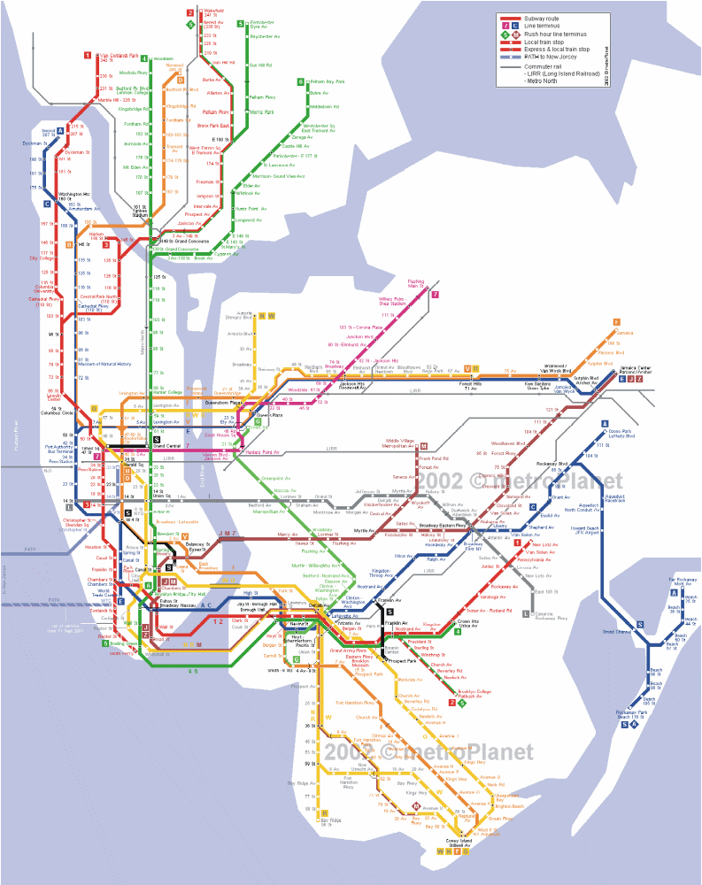

New York City

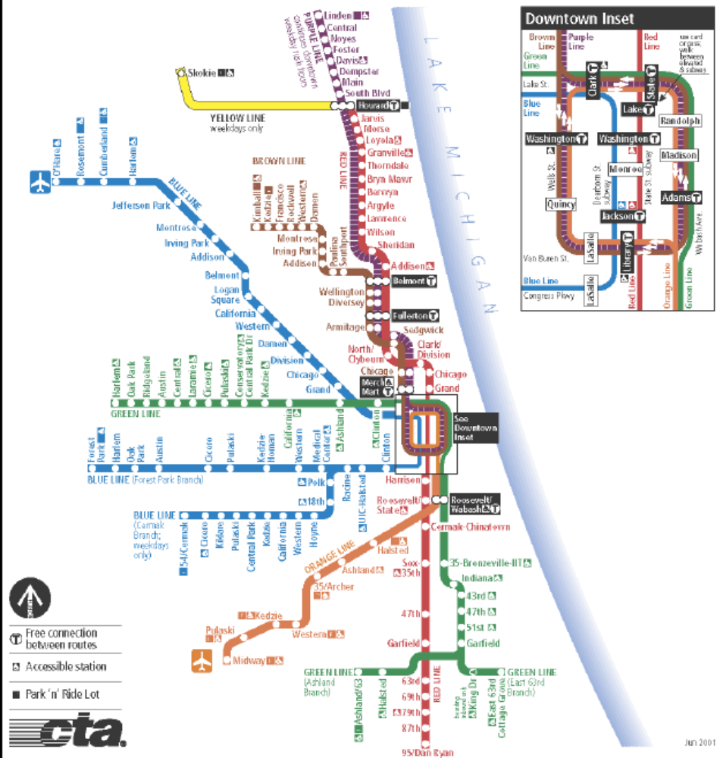

Chicago
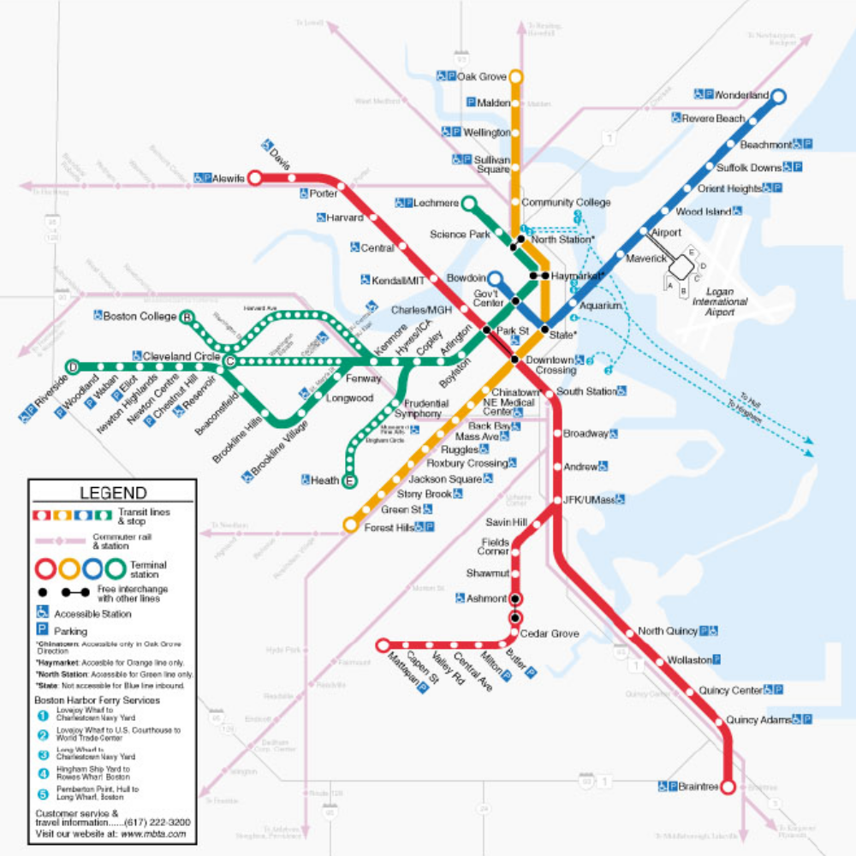

Boston

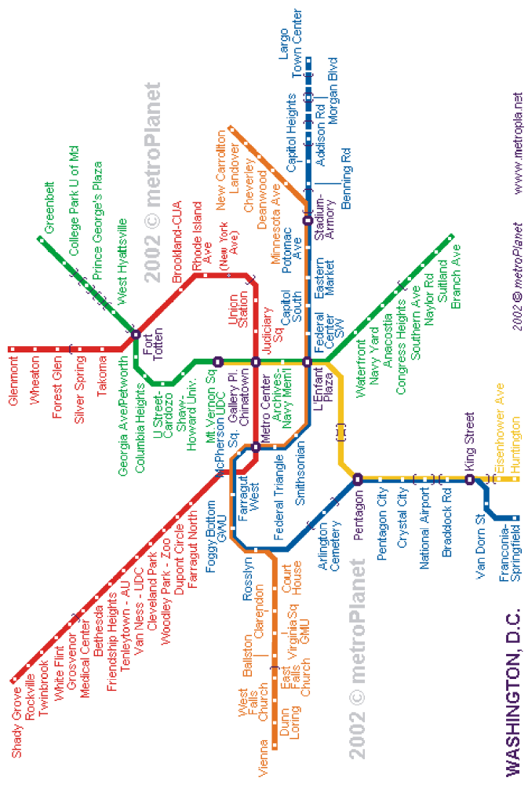

Washington

London

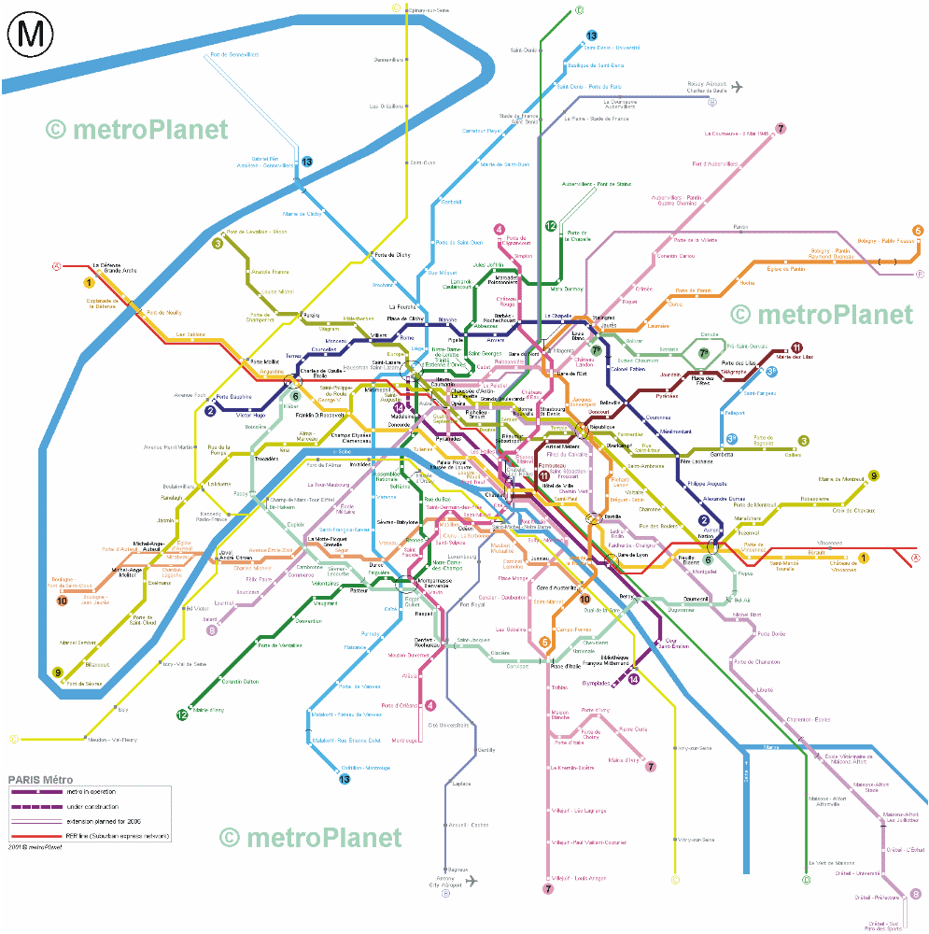

Paris

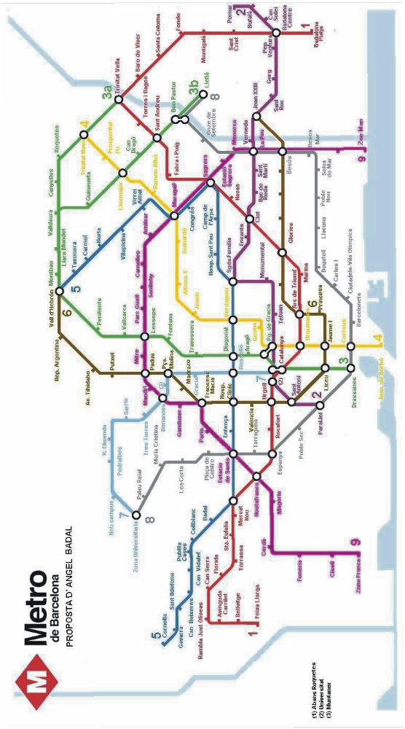

Barcelona

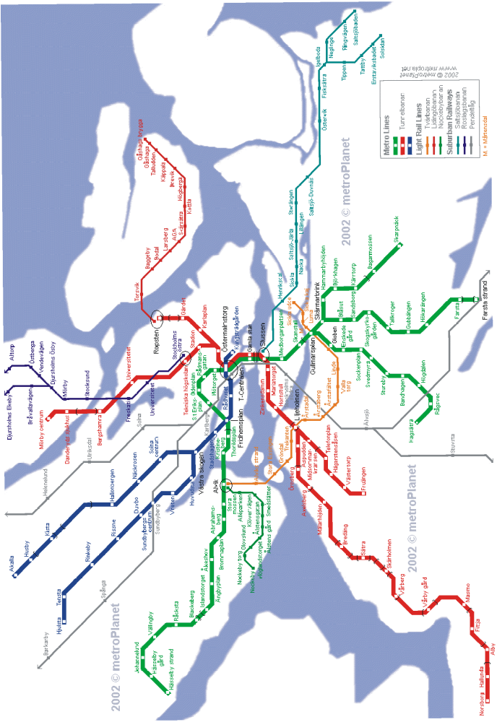

Stockholm

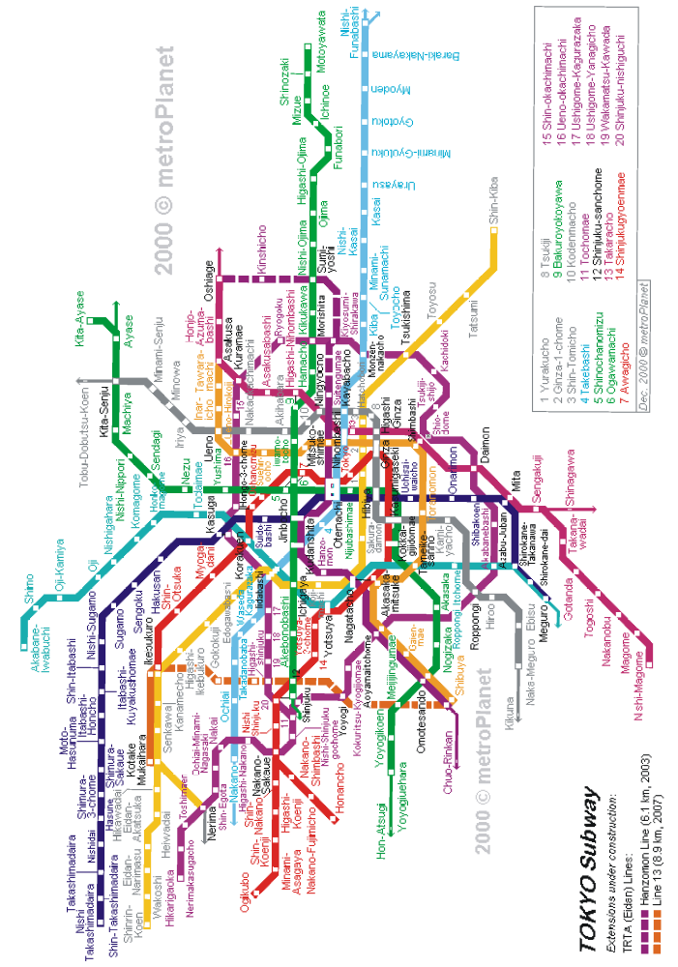

Tokyo

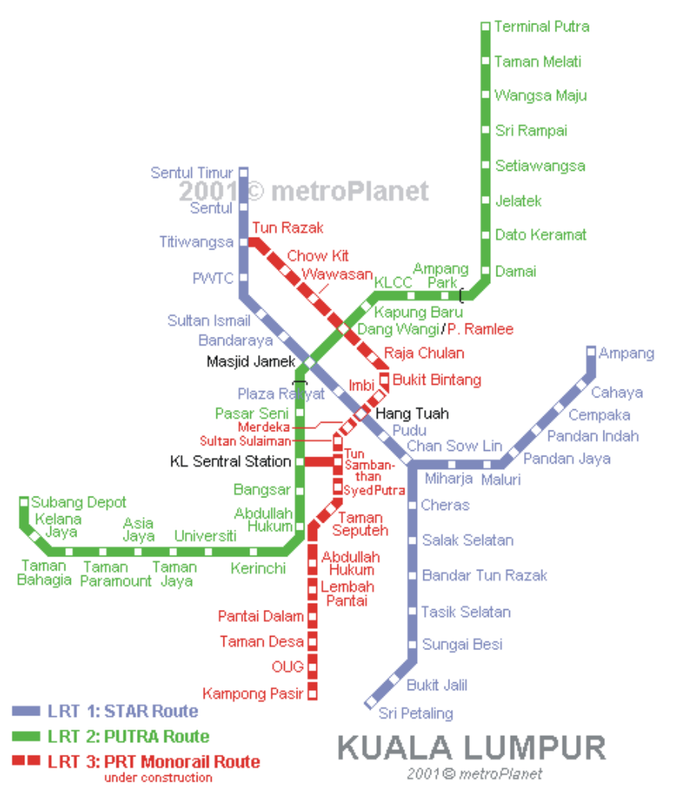

Kuala Lumpur

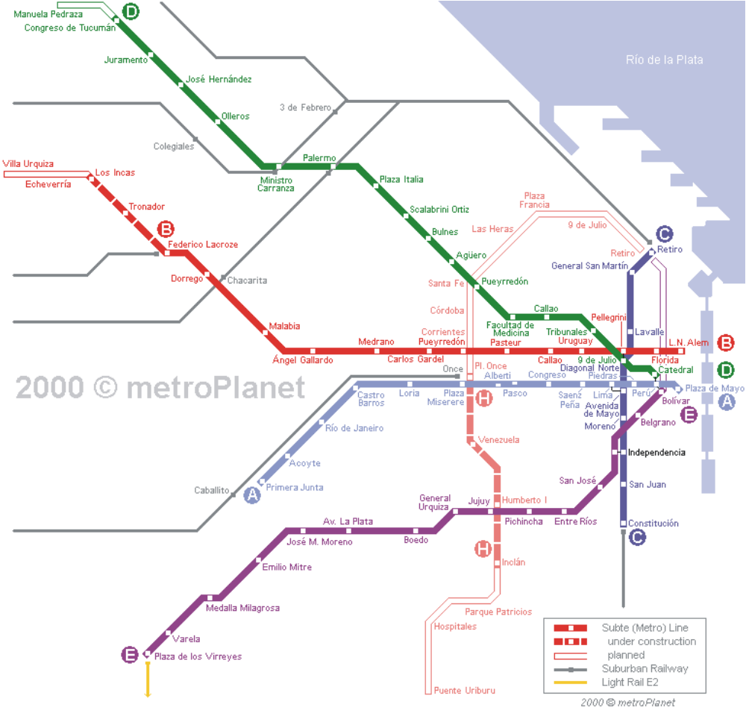

Buenas Aieres

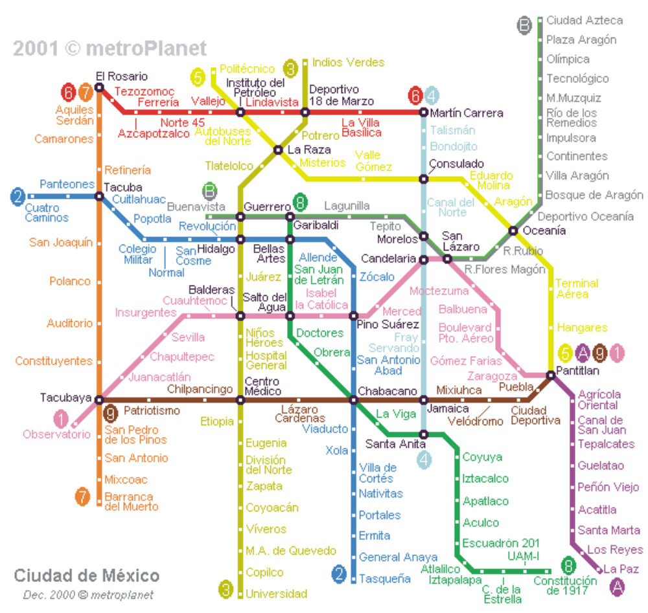

Mexico City

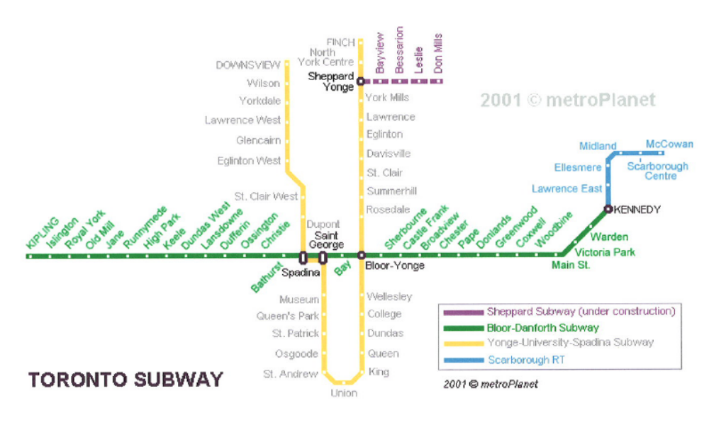

Toronto

APPENDIX TWO:

Photographs along Eglinton Avenue

Omitted from Electronic Version

APPENDIX THREE:

Subway stations under Options 1-4 and bus ridership on routes passing through stations constructed under Option 1 (the number of passengers passing across Eglinton Avenue will be much less in most cases). In-line transfer stations are indicated in bold.
Subway station under Option 1 | Daily bus ridership | TTC Route Numbers | Subway stations under other options
Subway station under Option 1 | Daily bus ridership | TTC Route Numbers | Option 2 | Option 3, 5 | Option 4
Martin Grove | 14,996 | 46, 111 | Yes | Yes | Yes
Kipling | 18,833 | 45 | Yes | Yes | Yes
Islington | 15,223 | 37 | Yes | Yes | Yes
Royal York | 8,423 | 73 | Yes | Yes | Yes
Scarlett | 6,634 | 79 | Yes | Yes | Yes
Jane | 39,896 | 35 | Yes | Yes | Yes
Weston/ Georgetown GO | 14,493 | 71 | Yes | Yes | Yes
Keele | 23,894 | 89 |  | Yes | Yes
Caledonia/Bradford GO | no data | 18 | Yes | Yes | Yes
Dufferin | 44,602 | 29 |  | Yes | Yes
Allen | Subway Line |  | Yes | Yes | Yes
Bathurst | 27,332 | 7 |  | Yes | Yes
Avenue | 4,053 | 5, 61,142 |  | Yes | Yes
Yonge | Subway Line |  | Yes | Yes | Yes
Mount Pleasant | 3,326 | 74, 103 |  |  | Yes
Bayview | 7,863 | 11 | Yes | Yes | Yes
Laird | 7,655 | 56, 88 |  |  | Yes
Leslie/Midtown & Richmond Hill GO | 37,916 | 51, 54 | Yes | Yes | Yes
Don Mills | 37,399  14,479 | 25  100 | Yes | Yes | Yes
Bermondsy | nil | 91 |  |  | Yes
Victoria Park | 31,036 | 24, 70 | Yes | Yes | Yes
Pharmacy | 5,892 | 67
Warden | 15,945 | 68
Birchmount | 10,866 | 17
Kennedy/Scarborough LRT | 16,967 | 43, 113 | Yes | Yes | Yes
Midland | 18,940 | 20, 57
Brimley/Danforth | 31,921 | 12, 16, 21
McCowan-Bellamy/Oshawa GO | 9,912 | 9, 86, 116 | Yes | Yes | Yes
Total Ridership | 496,205

LRT Stops under Option 2. Underground stations are indicated in bold.
Weston Road/GO | Heddington | Leslie/GO | Ionview
Black Creek Dr | Avenue Road | Don Mills | Kennedy Rd
Keele | Lascelles | Concorde/GO | Kennedy GO
Westside Mall | Yonge | Bermondsey | Midland
Caledonia/GO | Lillian | Jonesville | Falmouth
Dufferin | Mt Pleasant | Victoria Park | Brimley
Oakwood | Marmot | Pharmacy | Oswega
Allen | Bayview | New road #1 | McCowan
Eglinton West Village | Rumsey | Warden | Tornace
Bathurst | Laird | New road #2 | Eglinton GO
Spadina | Brentcliff | Birchmount

APPENDIX FOUR:

Cost Calculations for the Eglinton Avenue

Transportation Corridor

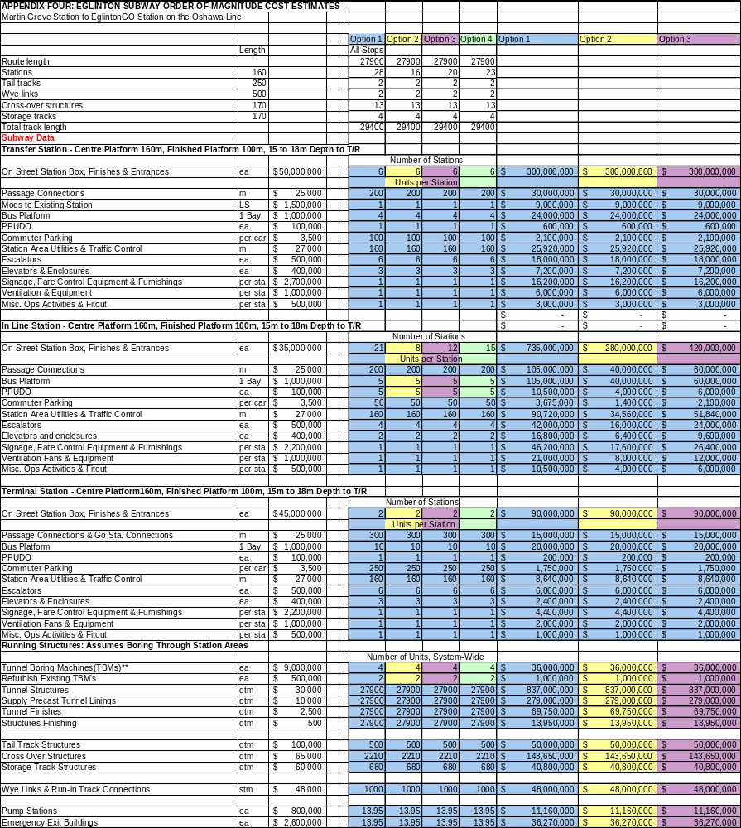
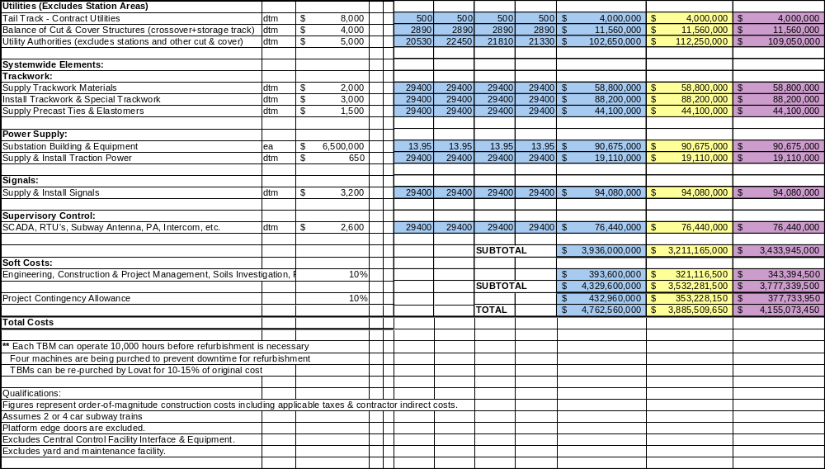

APPENDIX FIVE:

Estimation of Existing TTC Ridership

Close to Proposed Eglinton Avenue

Subway/LRT Stations

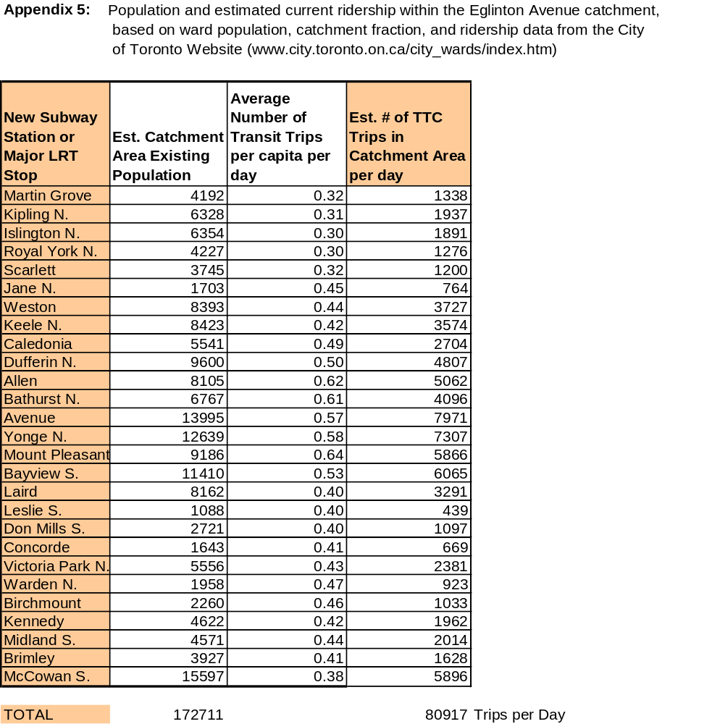

APPENDIX SIX:

Queen Street Subway stops under options one and two.
Subway Stop | Option One | Option Two
Dundas West on Bloor-Danforth subway line | Yes | Yes
Roncesvalles/Oakville GO line | Yes | Yes
Lansdowne | Yes
Dufferin/Georgetown-Bolton-Bradford GO line | Yes | Yes
Ossington | Yes
Trinity | Yes
Bathurst | Yes | Yes
Spadina | Yes | Yes
University | Yes | Yes
Yonge | Yes | Yes
Jarvis | Yes
Sherbourne |  | Yes
Parliament | Yes
Bayview/Richmond Hill GO line | Yes | Yes
De Grassi/Oshawa GO line | Yes | Yes
Carlaw | Yes
Jones | Yes
Greenwood | Yes | Yes
Coxwell | Yes
Woodbine | Yes | Yes
Lee | Yes
Balsam | Yes
Victoria Park South | Yes
Kingston Road | Yes
Gerrard | Yes
Denton/Victoria Park on Bloor-Danforth subway line | Yes
Main & Kingston |  | Yes
Main on Bloor-Danforth subway line |  | Yes

APPENDIX SEVEN:

Cost Calculations for the Queen Street

Subway

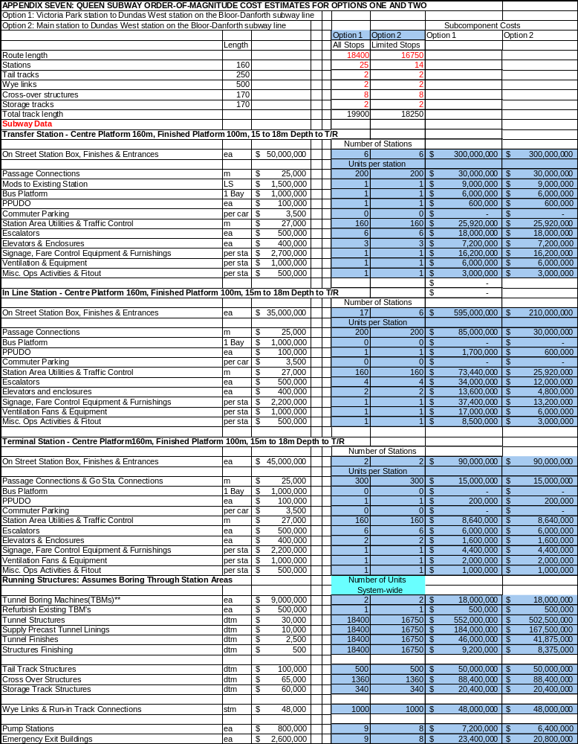
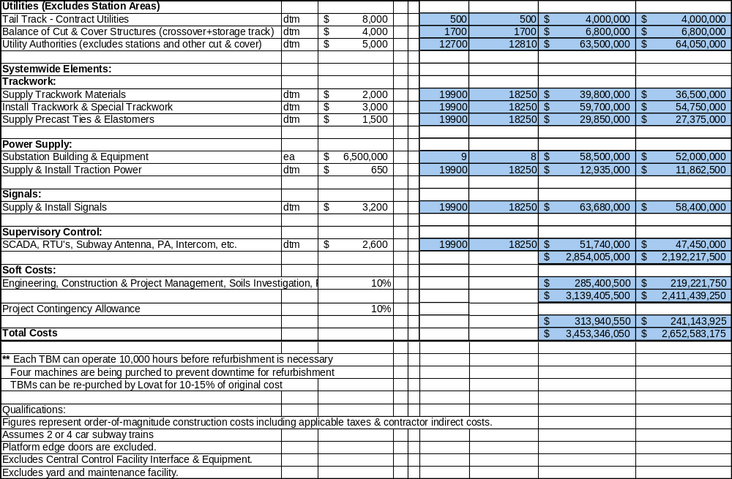

APPENDIX EIGHT: TUNNEL BORING MACHINES

The shield tunneling method was developed in the 19th century by Frenchman M. I. Brunel. It was first used in the London underground to tunnel beneath the Thames River, and has since been used in such famous projects as the Chunnel (Government of Tokyo, 2002). The machine used in this process is known as a tunnel boring machine (TBM), a cylindrical machine made up of three components: a forward shell, a stationary shell, and a trailing shield. Located on the front end of the forward shell is a cutting head that excavates the ground (using drag picks, scraper picks, or disk cutters) while hydraulic rams or thrust cylinders push the TBM forward. The excavated material (muck) passes through flood doors into a screw conveyor and is transported through the machine by conveyor and removed from the tunnel by rail cars. The machine is manned from an onboard control panel. A laser guided system monitors deviations from the predetermined alignment and grade. In 1994, subsoil advance exploration systems were added to TBMs and integrated into the cutting wheel to determine subsurface conditions up to 50 m in front of the machine. Results are displayed on-screen in the control booth. Problems such as boulders, or difficult soil and hydrological conditions, are identified.

Today’s machines are equipped with precast reinforced concrete segments (the lining), which are automatically erected and secured by bolts onto tunnel walls as the machine moves forward. The machines vary in size; those employed in the Sheppard line are 70 m long, weigh 235 tonnes, and have a thrust capacity of 3,000 tonnes. The lifespan of the machine before it must be refurbished is 10,000 hours. Continual improvements have been seen in tunnel boring technology. In the 1960s, fluid-supported shield machines were developed. In the 1970s earth-pressure balance (EPB) machines were created. These two forms of tunnel boring machines continue to be the most popular today. It is paradoxical that, while other major cities in the world continue to improve their subway networks and Toronto lags behind, one of the world’s leading manufacturers of TBMs – Lovat Technology – is based in Toronto.

The following images are examples of modern TBMs, capable of performing multiple tasks, including construction of subway platforms.

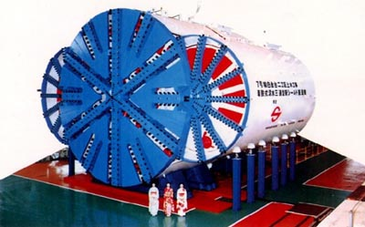
Figure 1. Removable Triple-Faced Slurry Shield

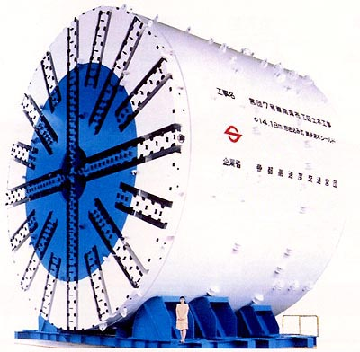
Figure 2. Parent–Child Slurry Shield

Cost, Benefits and Drawbacks

TBM costs have a significant range based on the size of the tunnel and the subsurface materials being excavated. In 1990 the TTC estimated that the cost per km of tunneling using TBMs was $28,000 (TTC, 1990). Capital costs are higher for TBMs than for drill and blast technology but operating costs are lower. While drill and blast costs may increase with distance, cost per metre for TBMs decreases as the tunnel length increases. A tunnel 1 km in length would cost 25% more per unit length than the cost of a 2 km tunnel (Government of Ontario, 1993).

There are multiple benefits to TBMs. The machines are able to cut through virtually any material, including hard rock, making them versatile. They are becoming increasingly popular over the drill and blast method of construction because mining can continue 24 hours/day. Boring (or advancement) rates range from 1m – 6m an hour (Holen, 2002). The volume of excavated materials is significantly less than that created by cut and cover methods. However, when boring through rock, the cutting teeth are worn down quickly. A primary drawback of the TBMs has been an inability to deal with large boulders or coarse gravel, although today’s TBMs are better equipped to handle this problem. The machines may also cause ground settlement of between 1%-2% (RTEP, 1995b). Tunnel boring machines have steadily progressed in their sizes, shapes, and technologies. Tunneling with this method minimizes disruptions to communities and traffic flow. The following diagrams illustrate the tunneling capabilities of modern TBMs. In addition to boring individual tunnels, TBMs are now being used in tandem to create the station platforms.

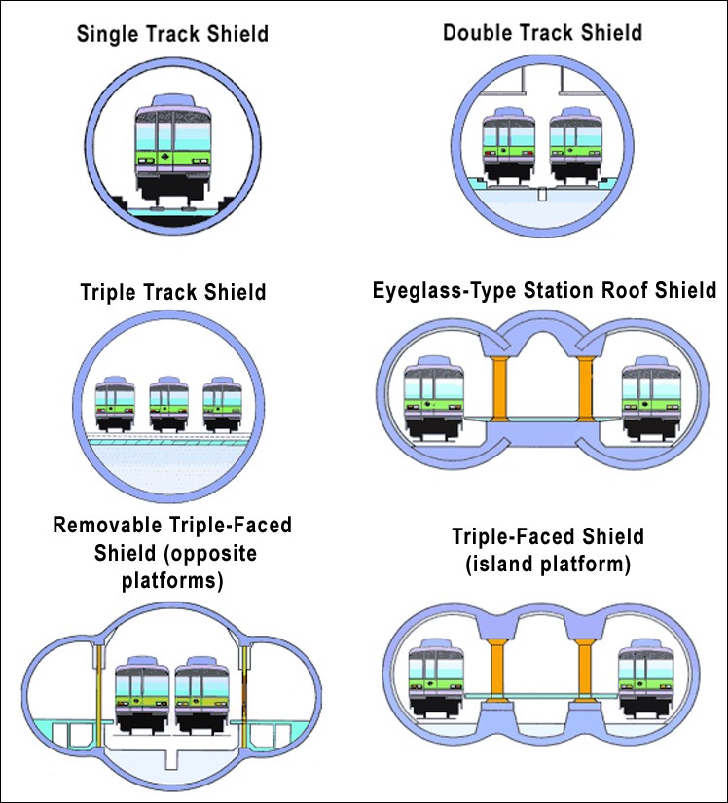
Figure 3. Subway Tunnel Types Source: Government of Japan (2002)

Future Methods

Tunneling has rapidly become the most popular form of subway construction, whether by drill and blast or through the use of TBMs. However, the cost and time savings associated with TBMs, in addition to their increased safety over the use of drill and blast, will likely lead to more use of this method. In Europe, 2,100 km of new transport tunnels are planned for construction in the next two decades. In Asia, similar plans are underway with 2350 km planned for construction. Most of the future advancements in tunneling technology will be improvements in their speed and tunneling accuracy. Automation of the machinery, remote controlled systems, and increased mechanization such as robotics can be expected. The largest diameter for TBMs is currently 14.2 m and is being used on the 4th Elbe Tunnel Tube in Hamburg. Diameters of 15-16 m are expected in the near future. Other improvements will include fewer negative effects on surface layers and improvements to the subsoil advance exploration systems (Haack, 2001).

Eglinton Avenue

Construction of an Eglinton subway would include cut and cover construction for the stations, TBM launch and removal shafts, cross passages and emergency exits. Four earth-pressure balance TBMs would be used for the remainder of the line. Four machines are necessary due to the length of the line and in order to minimize downtime associated with the refurbishment of machines after every 10,000 hours. These machines would tunnel at a depth ranging from 4m to 24m. The TBMs would be approximately 5.2 m – 5.9 m in diameter (Ball et al., 1996). For station construction, previous Eglinton West studies have shown that tunneling through the station area and then excavating downwards using cut and cover to remove tunnel liner segments may be the most cost-effective method of building the subway. This method does not require the removal of the TBMs from the earth. Figure 4 depicts the type of Lovat technology that would be employed.

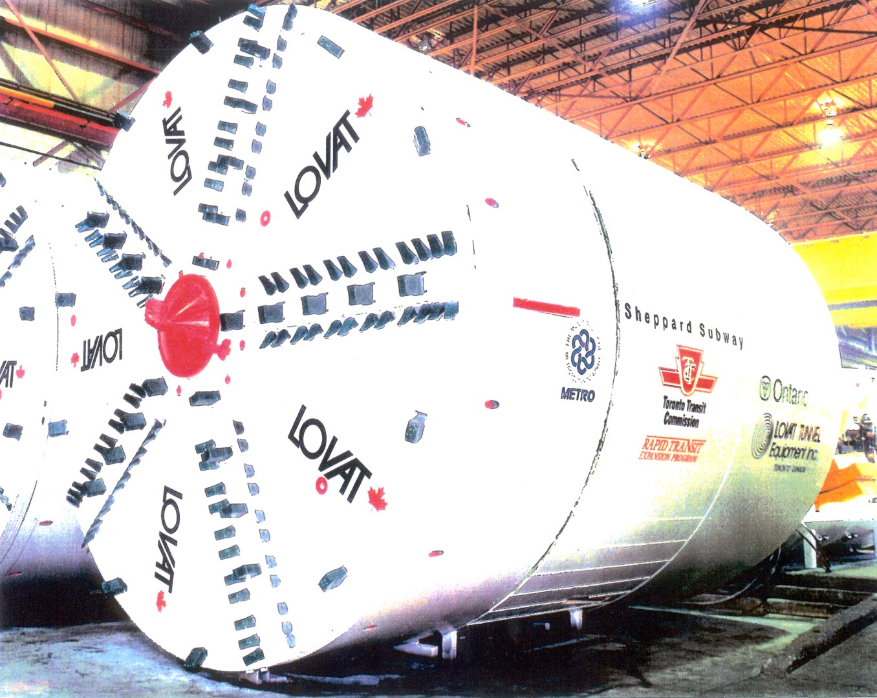

Figure 4. Lovat Tunnel Boring Machine Source: Trisi (2002)

More stringent emission standards for new vehicles in the USA (and presumably in Canada) will see a drop in regulated emissions by a factor of 2-5 (depending on the pollutant) between 1993 and 2010. However, the gap between regulated and actual emissions is expected to grow, such that the emissions will fall by no more than a factor of two (Williams et al, 2000). Large reductions are feasible for electricity production, the other major source of air pollution.
In the map of the New York subway system shown in Appendix 1, stops for express trains are indicated by black squares.
Existing subway lines: Bloor-Danforth, 26.2 km; Yonge-University-Spadina, 30.2 km; Sheppard, 6.4 km. New subway lines: Queen, 16.8 km; Eglinton, 29.4 km; Yonge-University link, 14.7 km; Bloor-Danforth extension, 5.3 km; Sheppard extensions, 19.2 km; Martin Grove, 12.3 km.
In 1998 the TTC had 620 subway cars servicing 56 km of subway line, or 11 cars per km. However, the initial subway lines that we would build would be express subway lines, which would require fewer cars to carry the same number of people and with the same wait between trains as in a regular subway line.
Mr. Thwaite has informed us that there is a street in Munich in which four rail lines are stacked underground, one on top of another, with separate escalators from the surface to each line.
The numbers are not strictly comparable, since the highway data are flows passing a single line, while the TTC data are total passengers on a given route, not all of whom cross any given line. However, this is the closest comparison that we can make, given the available data, and it is still a useful indicator of the relative unimportance of the major highways (for non-freight movements) compared to public transit.
A tax of 10 cents/litre increases the annual cost of an automobile, including insurance, maintenance, and depreciation, by only a few percent, and is substantially less than the cost to society of air pollution damage caused by the use of gasoline. For Toronto’s population density, this damage is on the order of 25-75 cents/litre based on comparison with the European Commission ExternE study (Spadaro, 1998), depending on the economic value that one assigns to premature death (assuming that one is even willing to assign an economic value to human death).
The above information was compiled from RTEP (1995d), Trisi (2002), Haack (2001), and TTC (date unknown).
Skelhorn et al. (1998) report rates of 15 m per day on the Sheppard subway line.

